**Summary Statistics about PM2.5 data**

Firstly, we want to provide a basic set of descriptive statistics for the pm2.5 data. There is a total count of 2067 missing values in the data, which we filtered for. We ran a quick summary for the data, shown below: 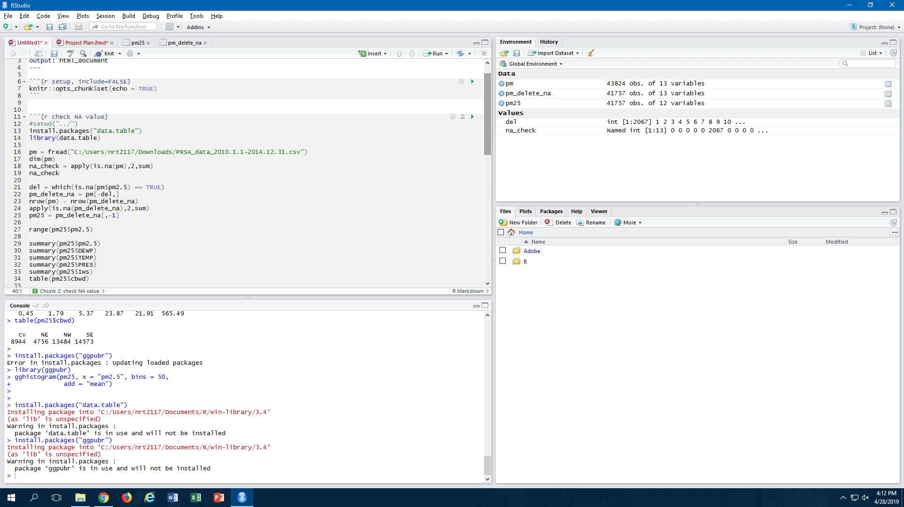

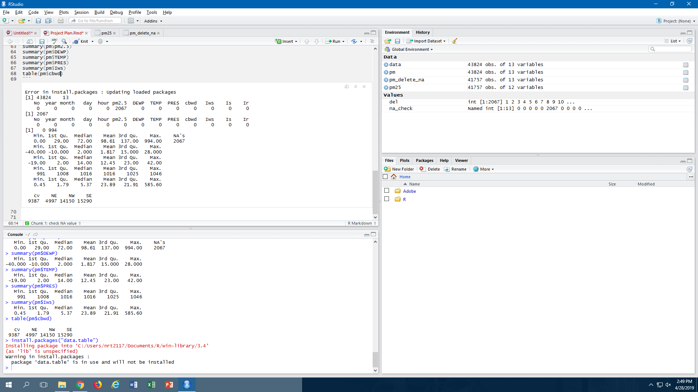

**PM2.5**

According to the World Health Organization’s findings, the highest PM2.5 level for acceptable air quality is 25 micrograms per cubic meter. Our data set shows that the median PM2.5 level in Beijing registers approximately 3 times the recommended level. We used the air quality guide provided by the US government to separate the PM2.5 values into the following levels:

|  |  |
| --- | --- |
| **Air Quality Index** | **PM2.5 Level (microgram per cubic meter)** |
| Good | 0 - 50 |
| Moderate | 51-100 |
| Unhealthy for Sensitive Groups | 101-150 |
| Unhealthy | 151-200 |
| Very Unhealthy | 201-300 |
| Hazardous | 301-500 |
| Beyond Index | >500 |

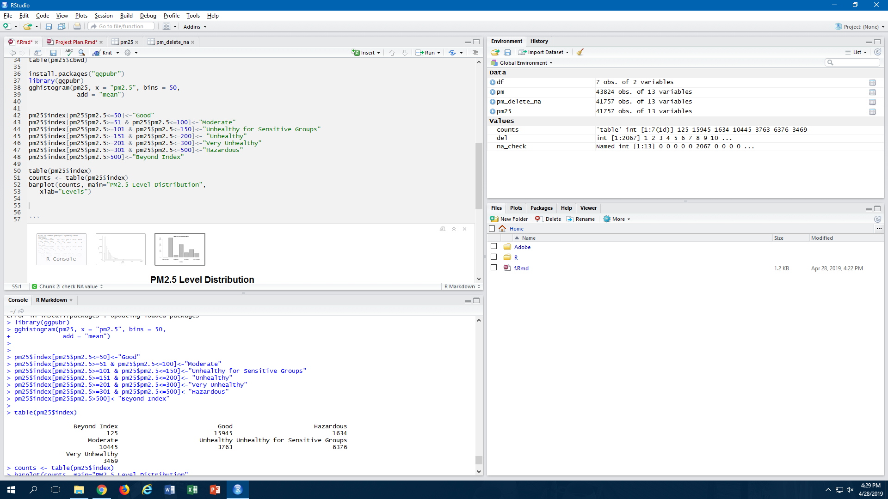

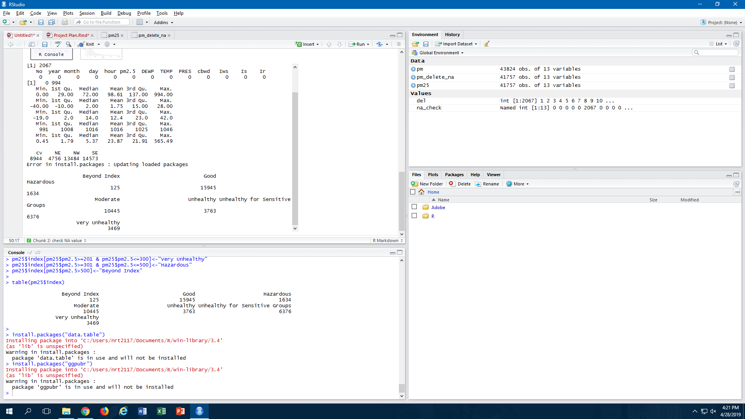

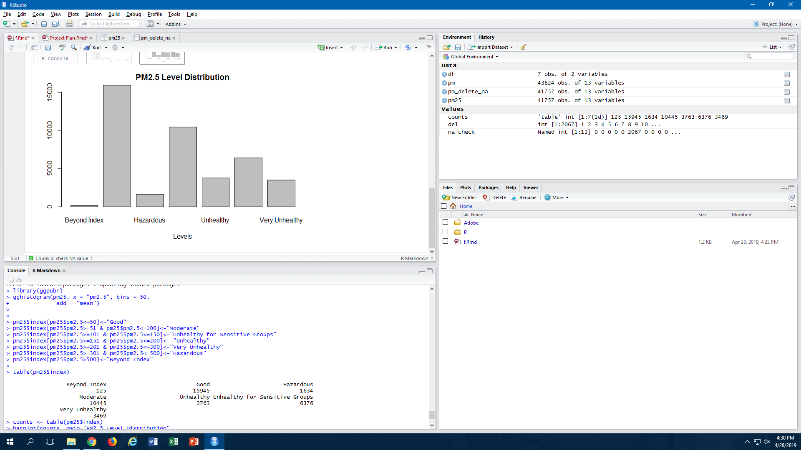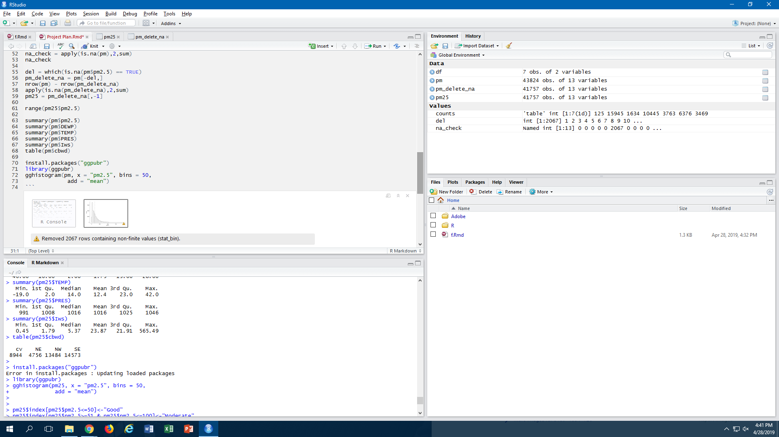

From the data exploring conducted, we found that, approximately, only 63% of the registered PM2.5 levels in Beijing registered in the “Good” or “Moderate” category. Approximately 12.5% of all levels were registered in the “Very Unhealthy / Hazardous / Beyond Index” categories. We can also see from the graph below that the distribution of PM2.5 levels has a strong positive skew.

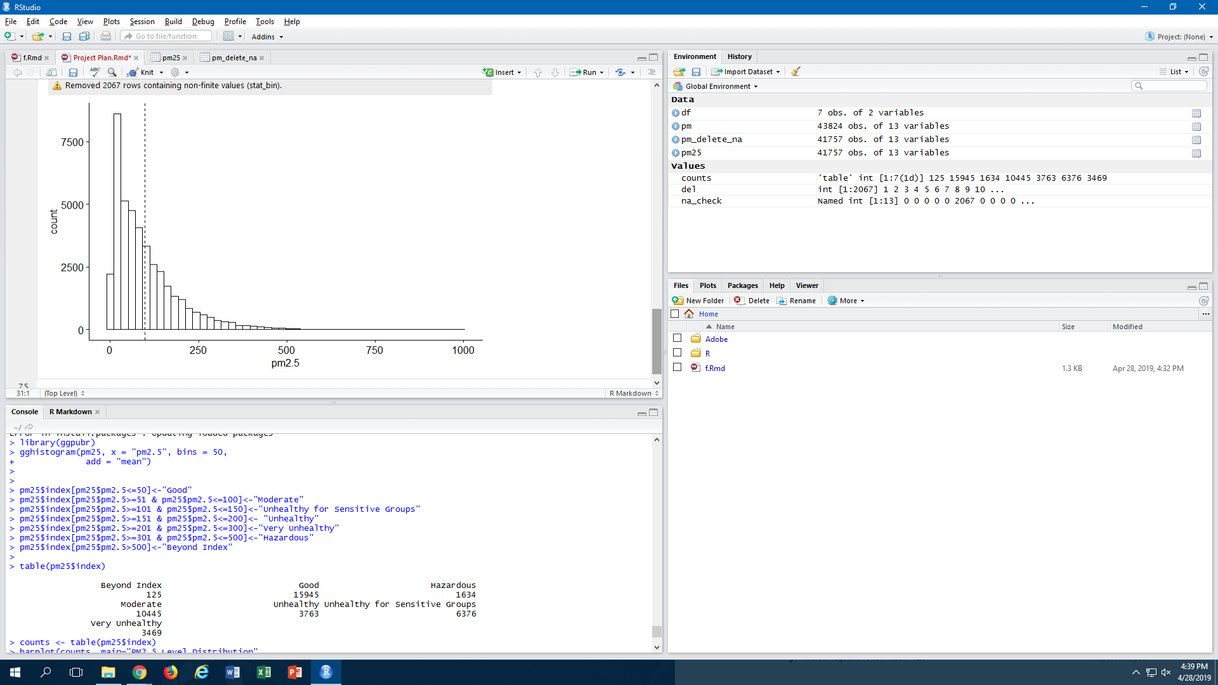

We also wanted to examine the cluster months in each of the four years to see how PM2.5 level distribution changed ie. establish a pattern according to the period of the year.

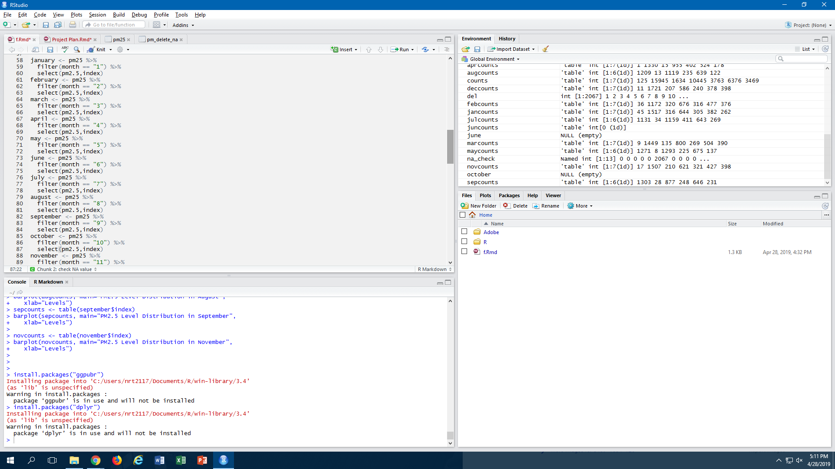

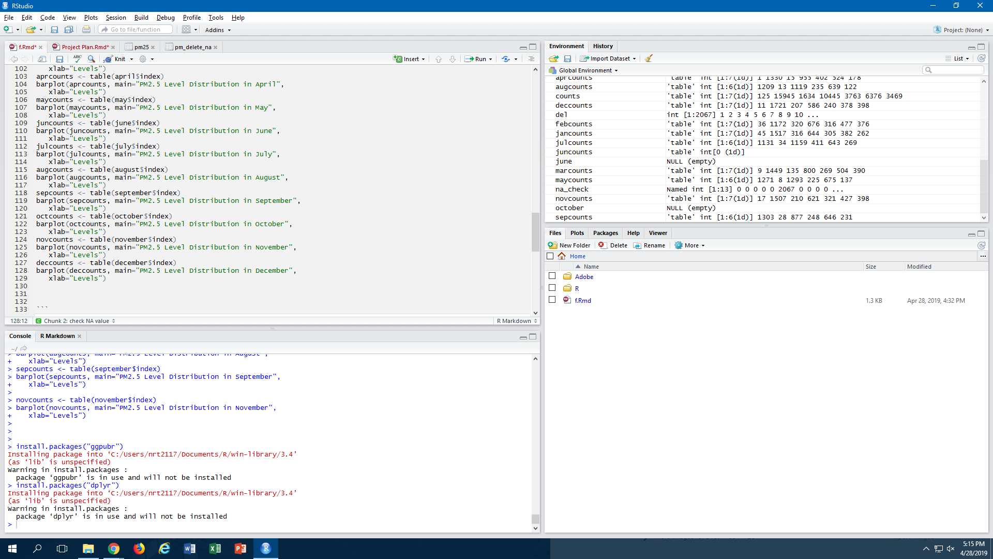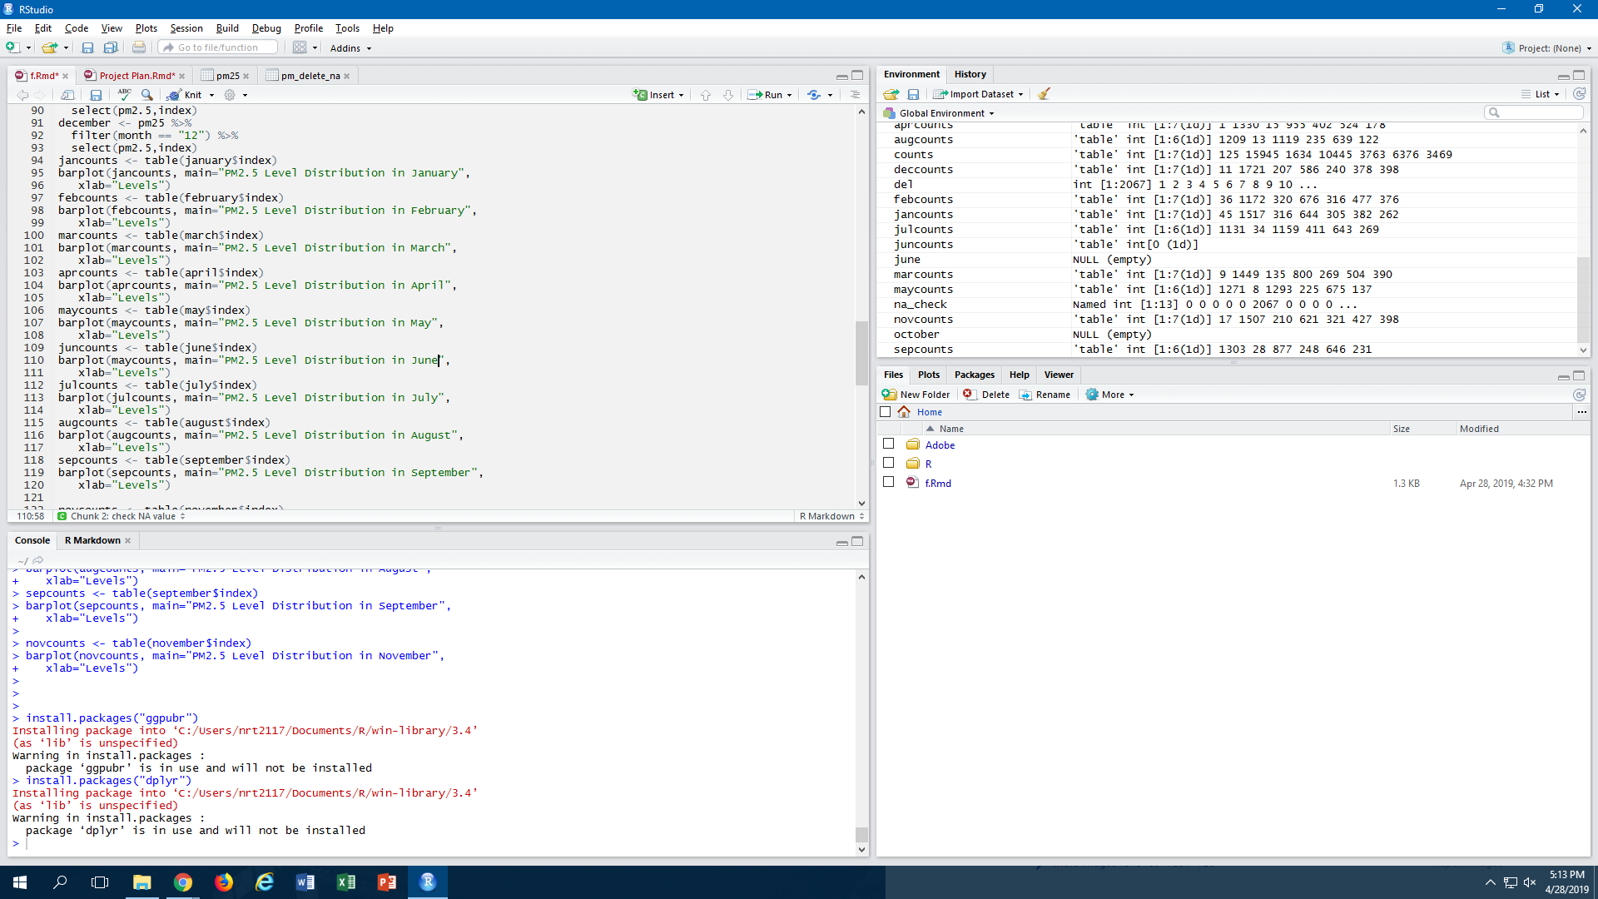

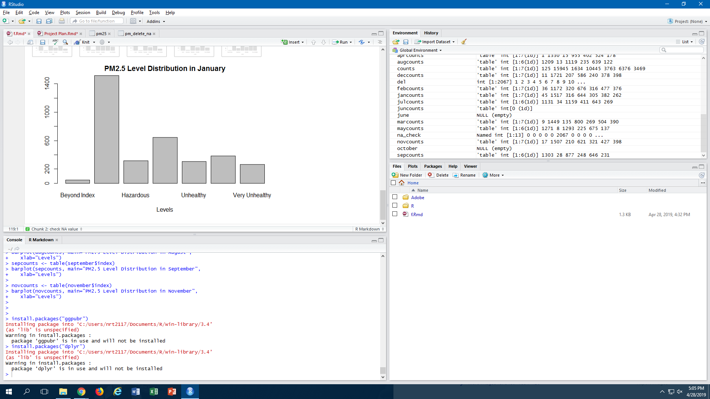

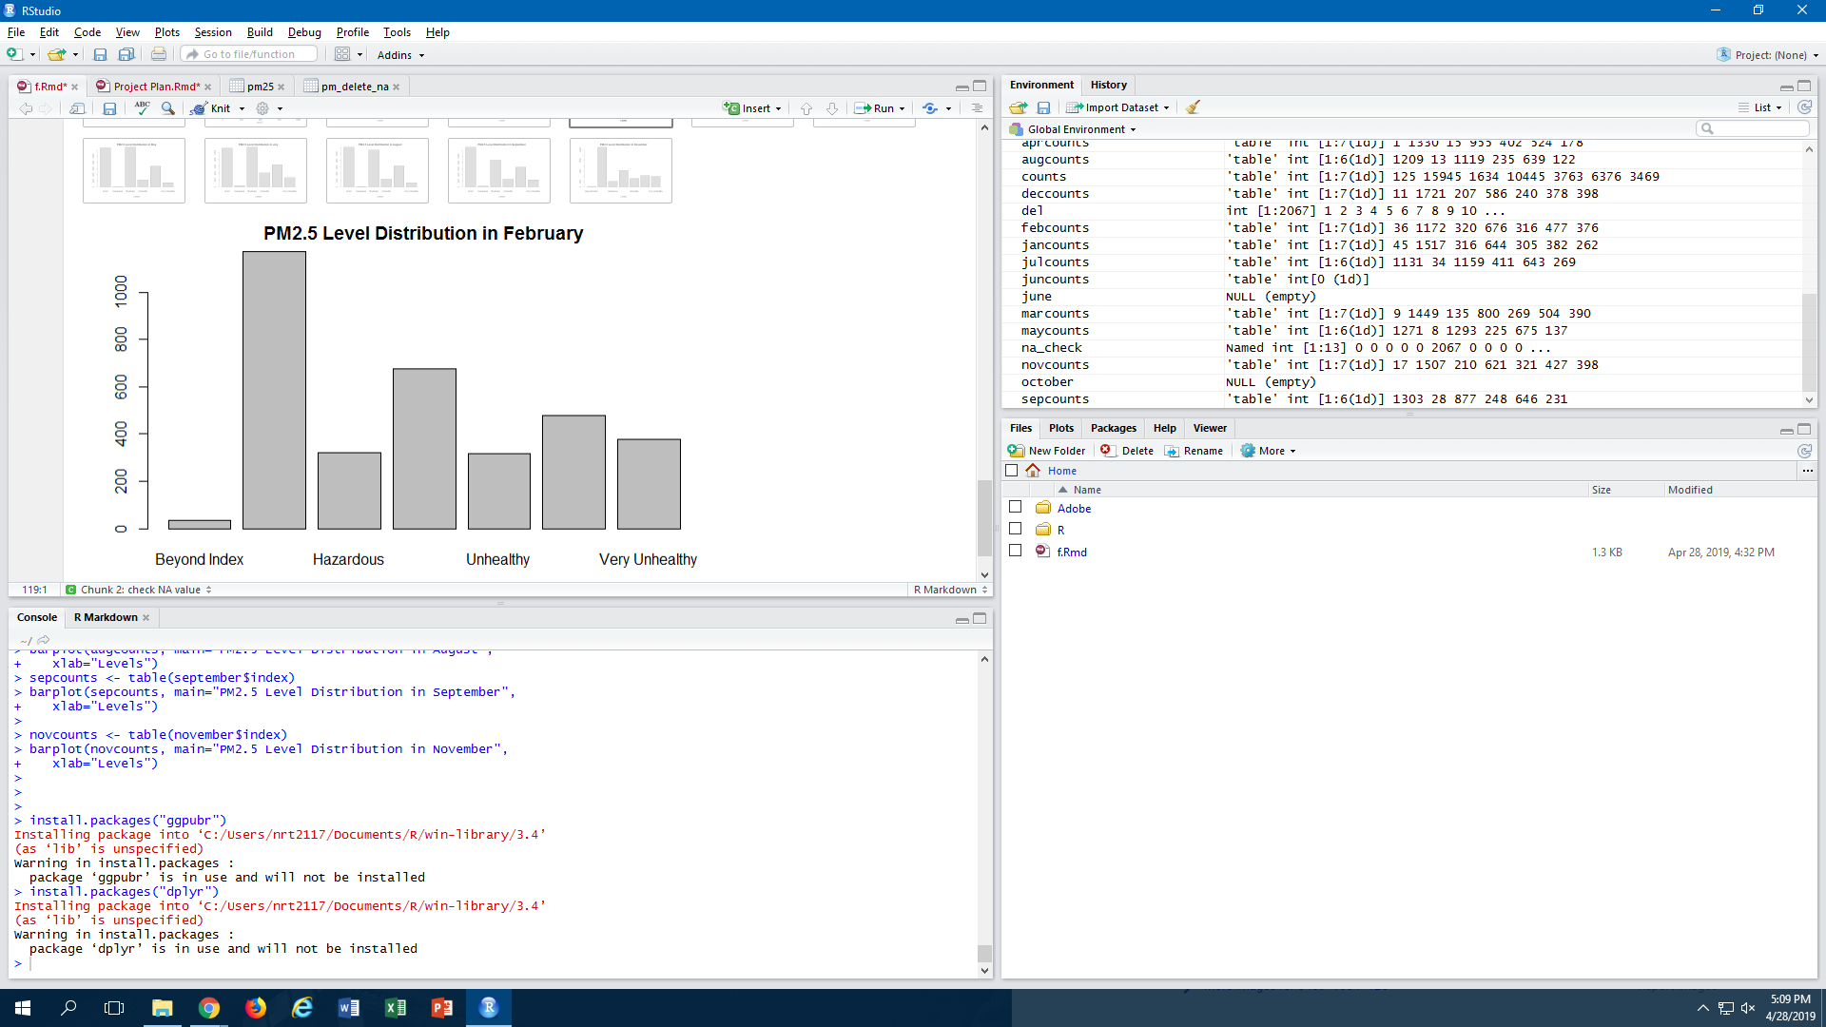

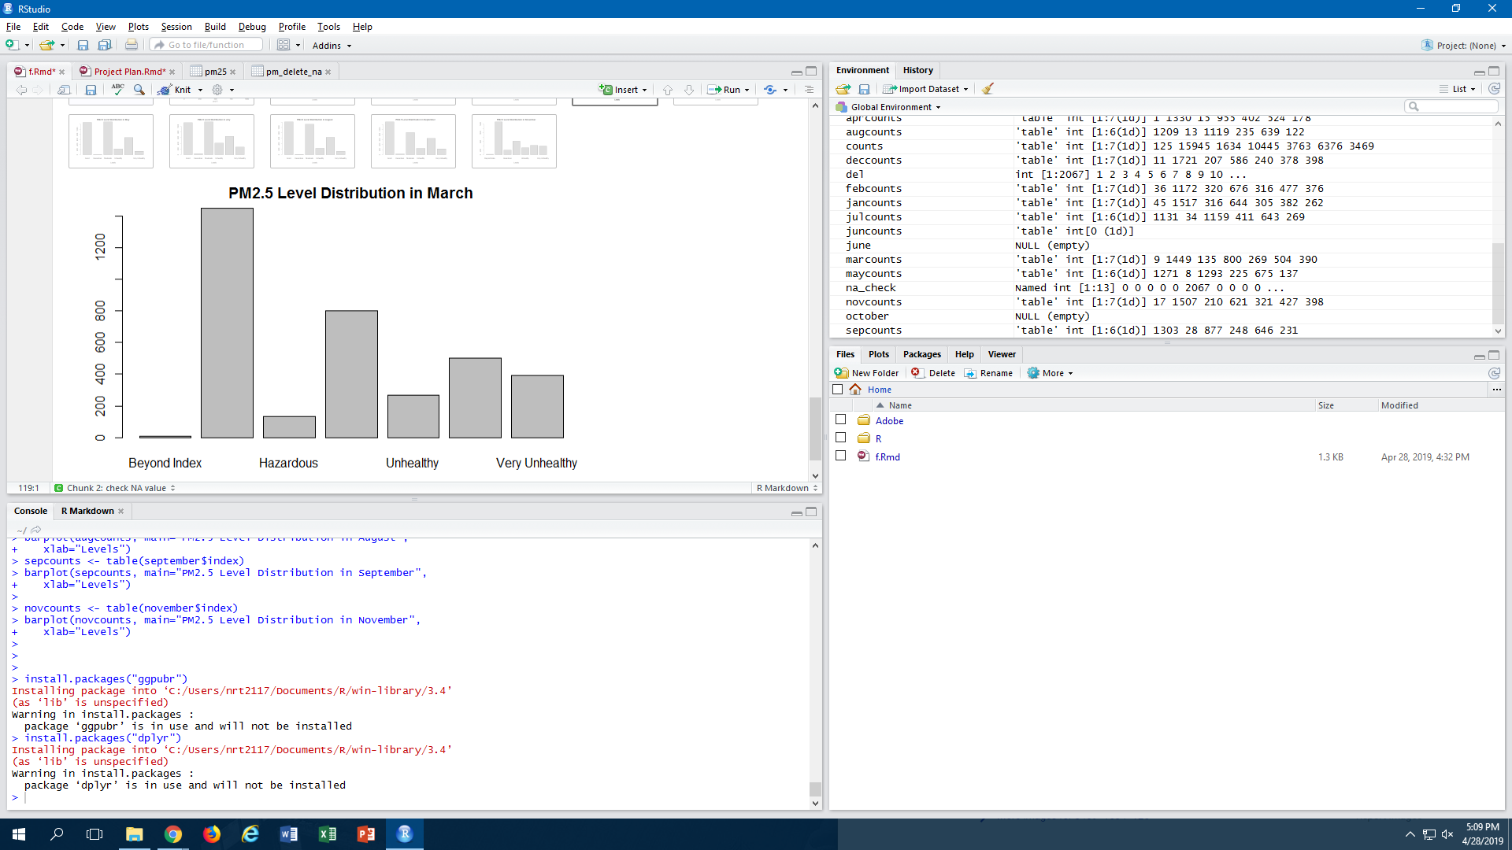

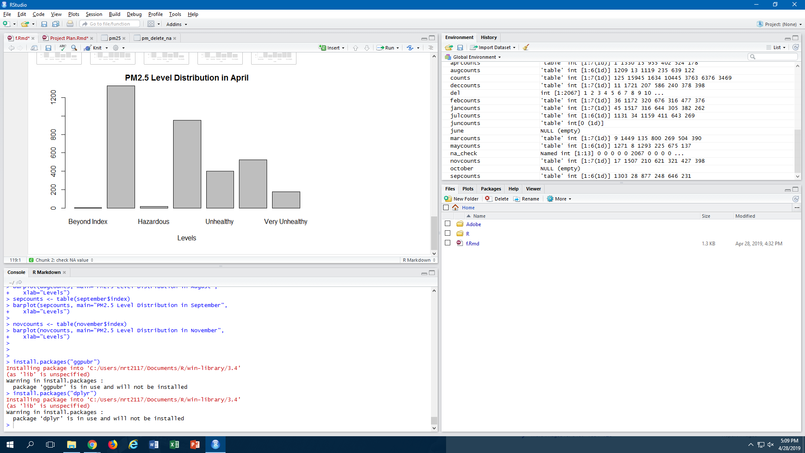

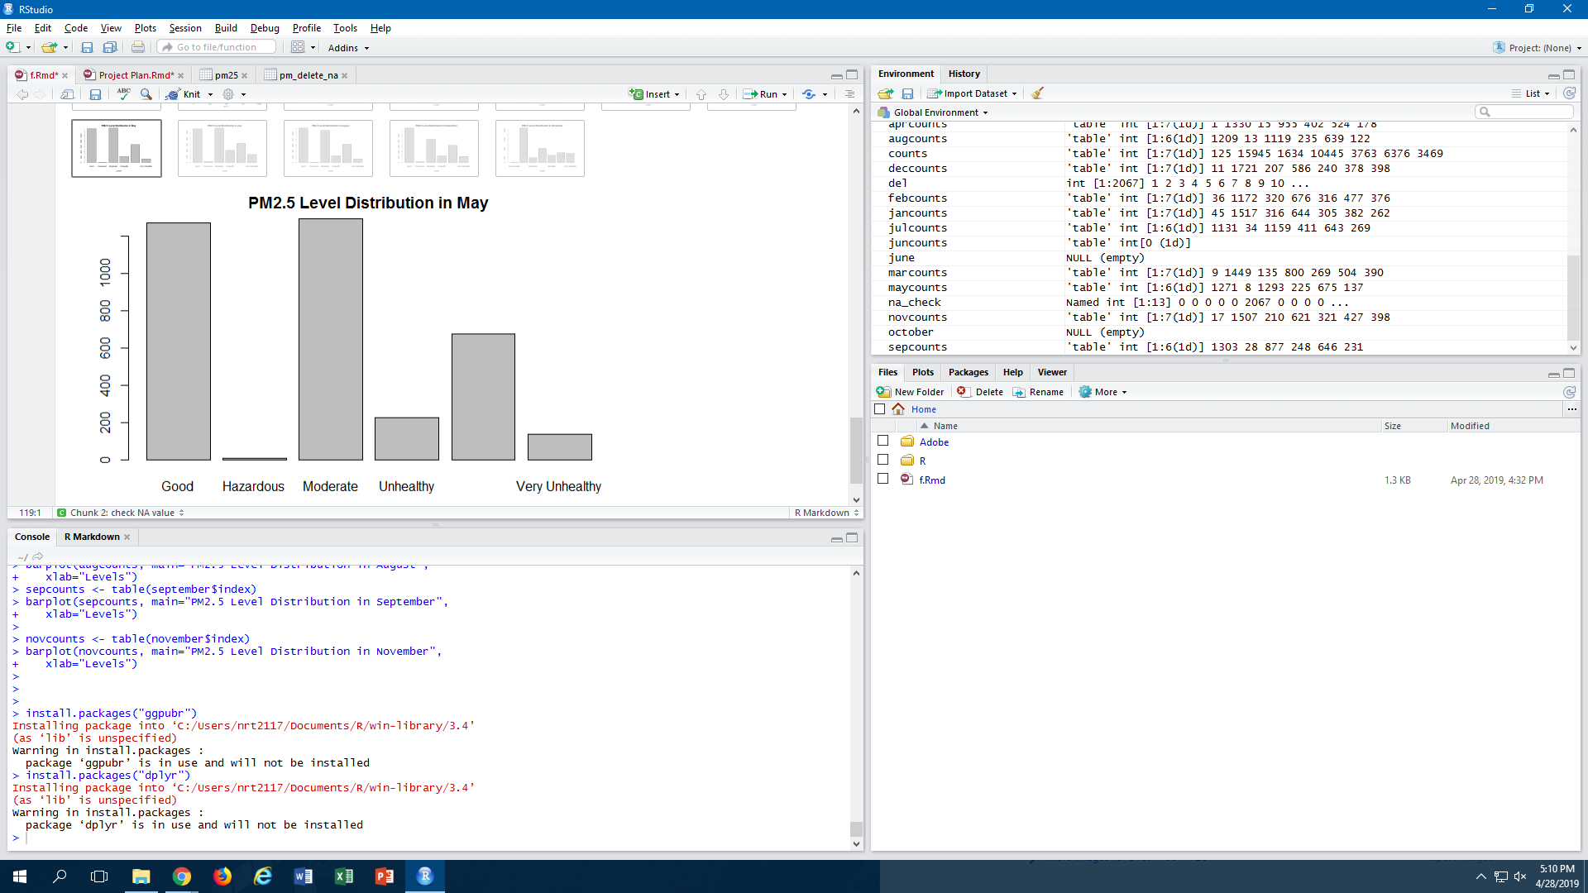

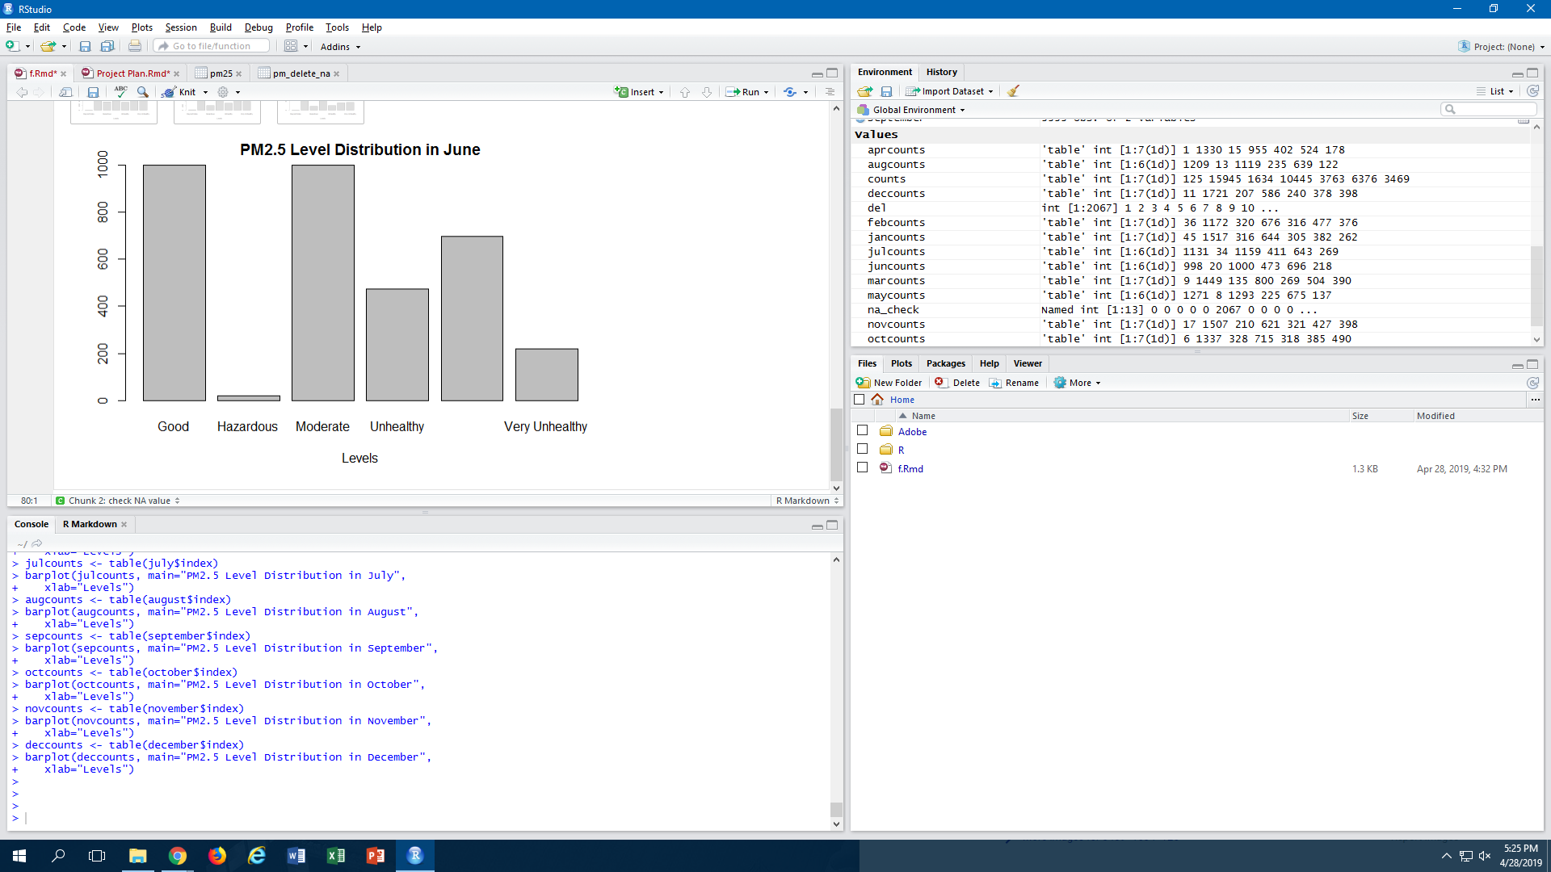

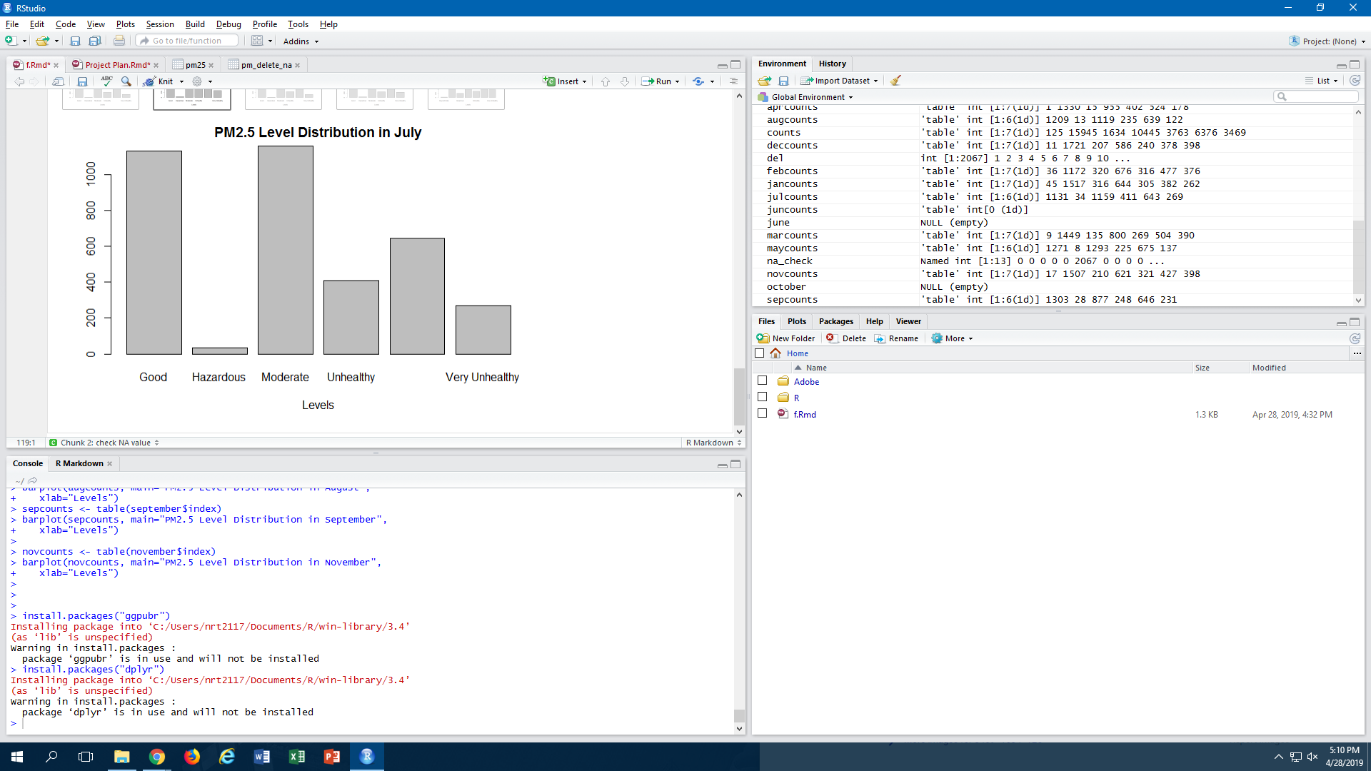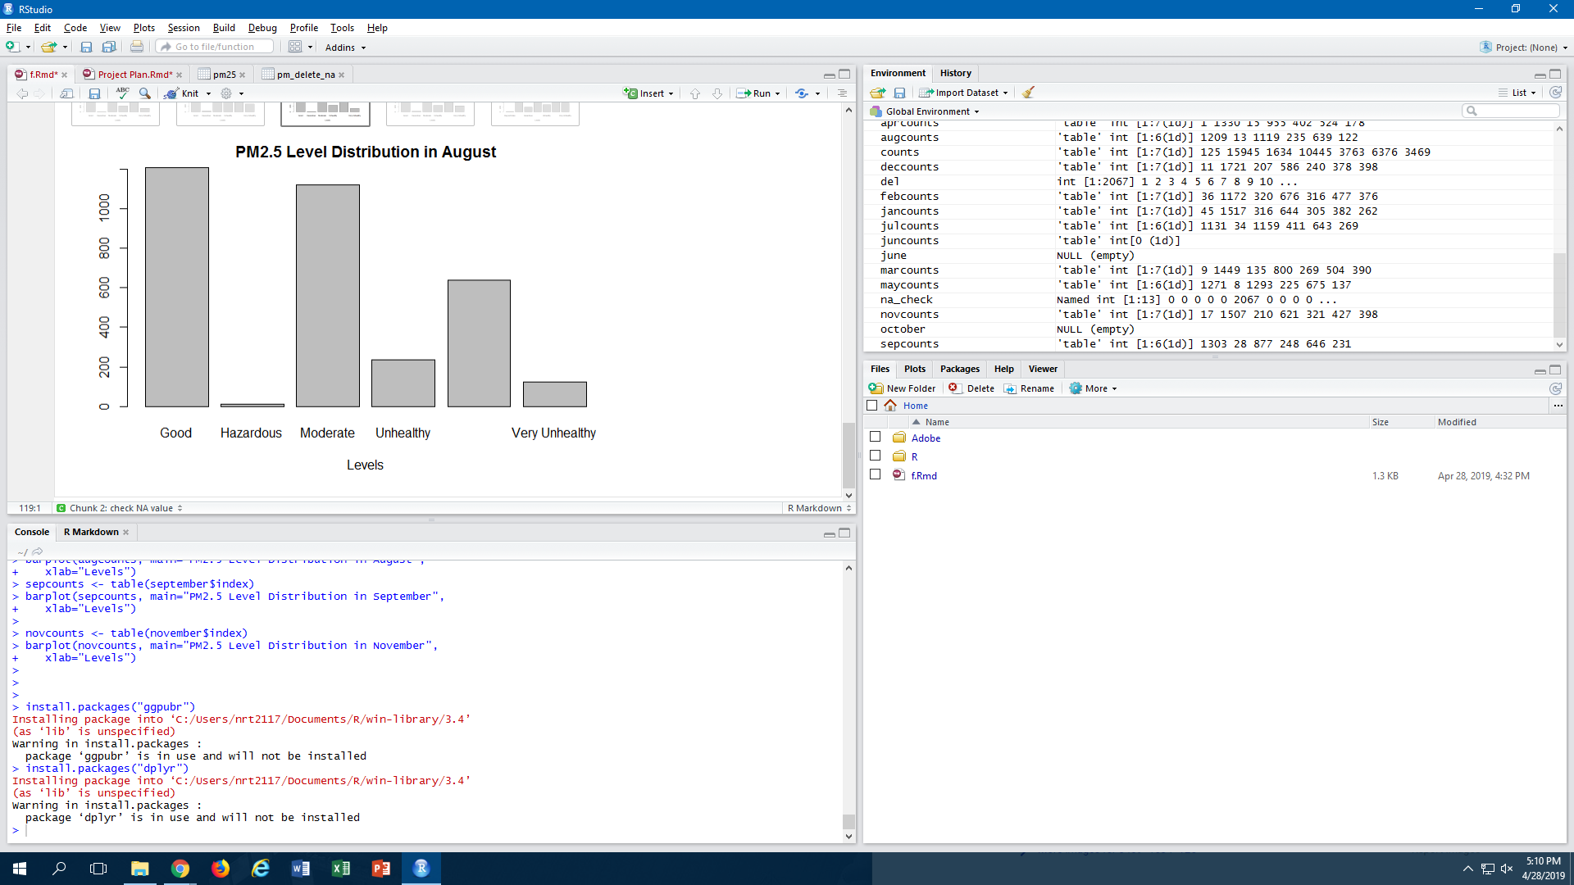

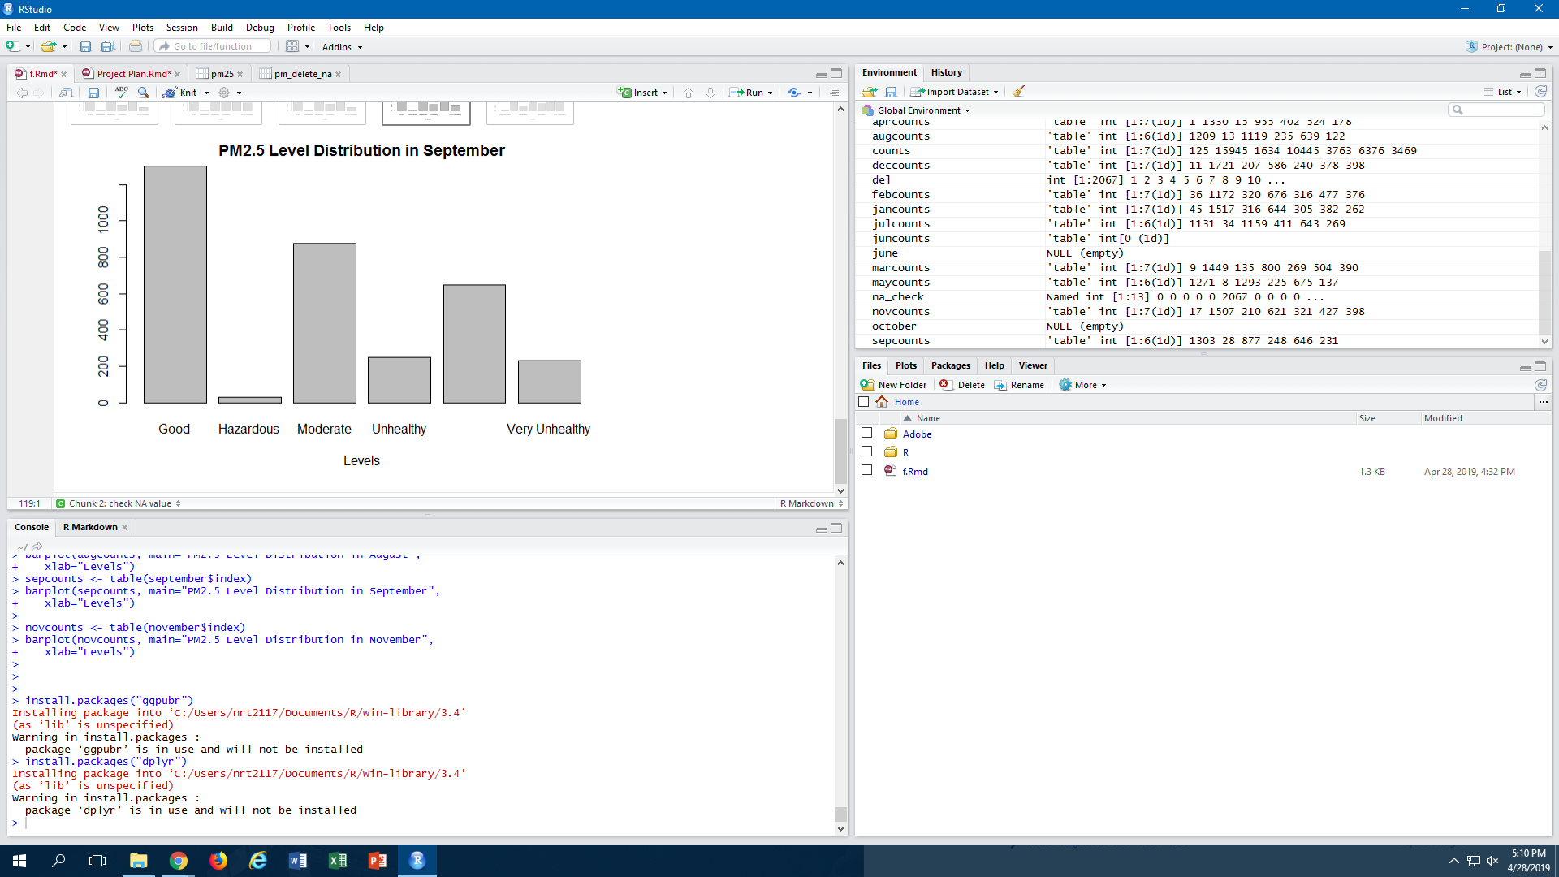

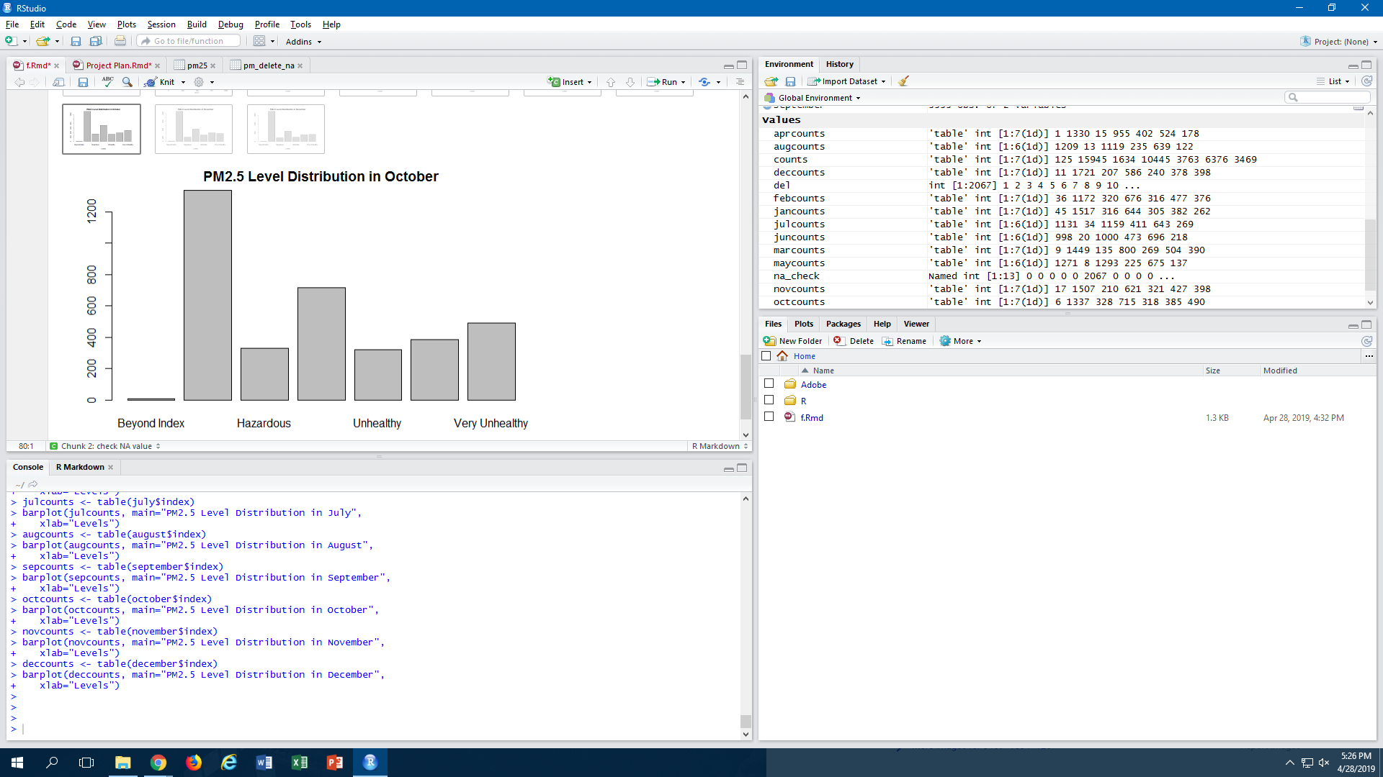

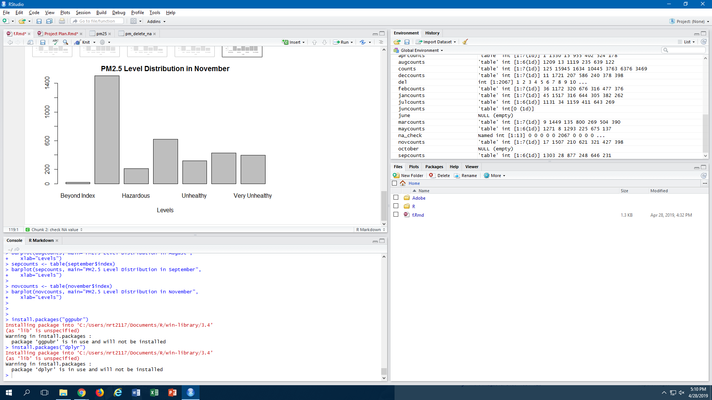

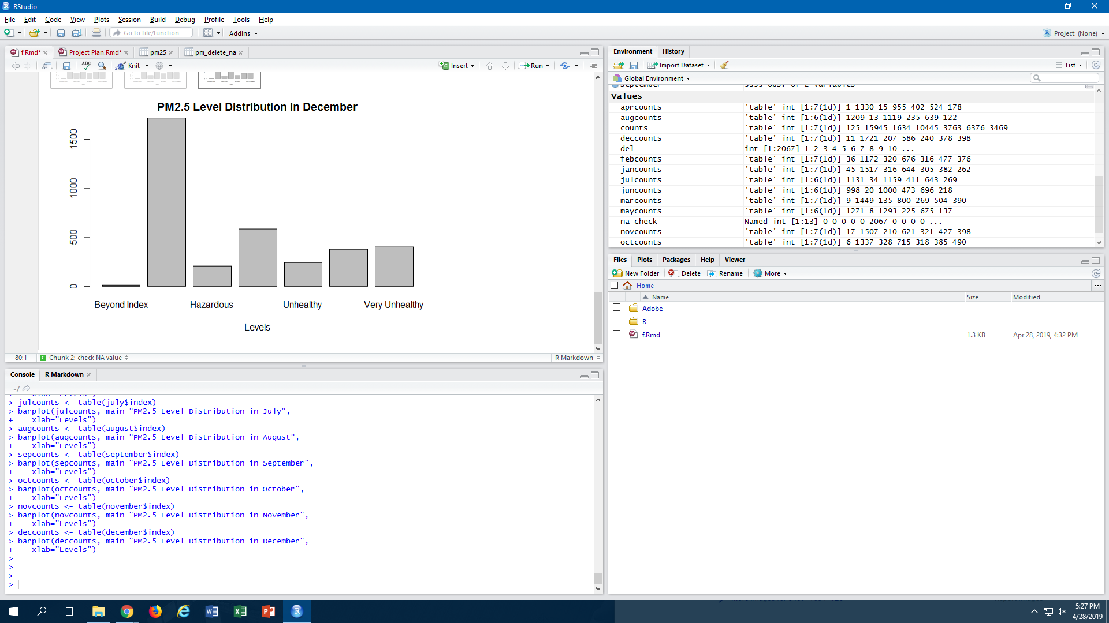

From the graphical representation above, we can summarize the following about the clustered months:

|  |  |  |
| --- | --- | --- |
| **Month** | **Proportion of “Very Unhealthy / Hazardous / Beyond Index” Category** | **Summary** |
| January | 17.9% | Higher than total average |
| February | 21.7% | Higher than total average |
| March | 15.0% | Higher than total average |
| April | 5.7% | Lower than total average |
| May | 4.0% | Lower than total average **(LOWEST)** |
| June | 7.0% | Lower than total average |
| July | 8.3% | Lower than total average |
| August | 4.0% | Lower than total average **(LOWEST)** |
| September | 7.8% | Lower than total average |
| October | 23.0% | Higher than total average **(HIGHEST)** |
| November | 17.9% | Higher than total average |
| December | 17.6% | Higher than total average |

It is clear that there is a seasonal distribution in PM2.5 levels, as the winter/autumn months tend to have a much higher average PM2.5 level than the summer/spring months. For 6 months continuously, the air quality, on average, falls into the “Very Unhealthy / Hazardous / Beyond Index” category over 15% of the time.

Now, let’s take a look at the PM2.5 level distribution within a 24-hour period.

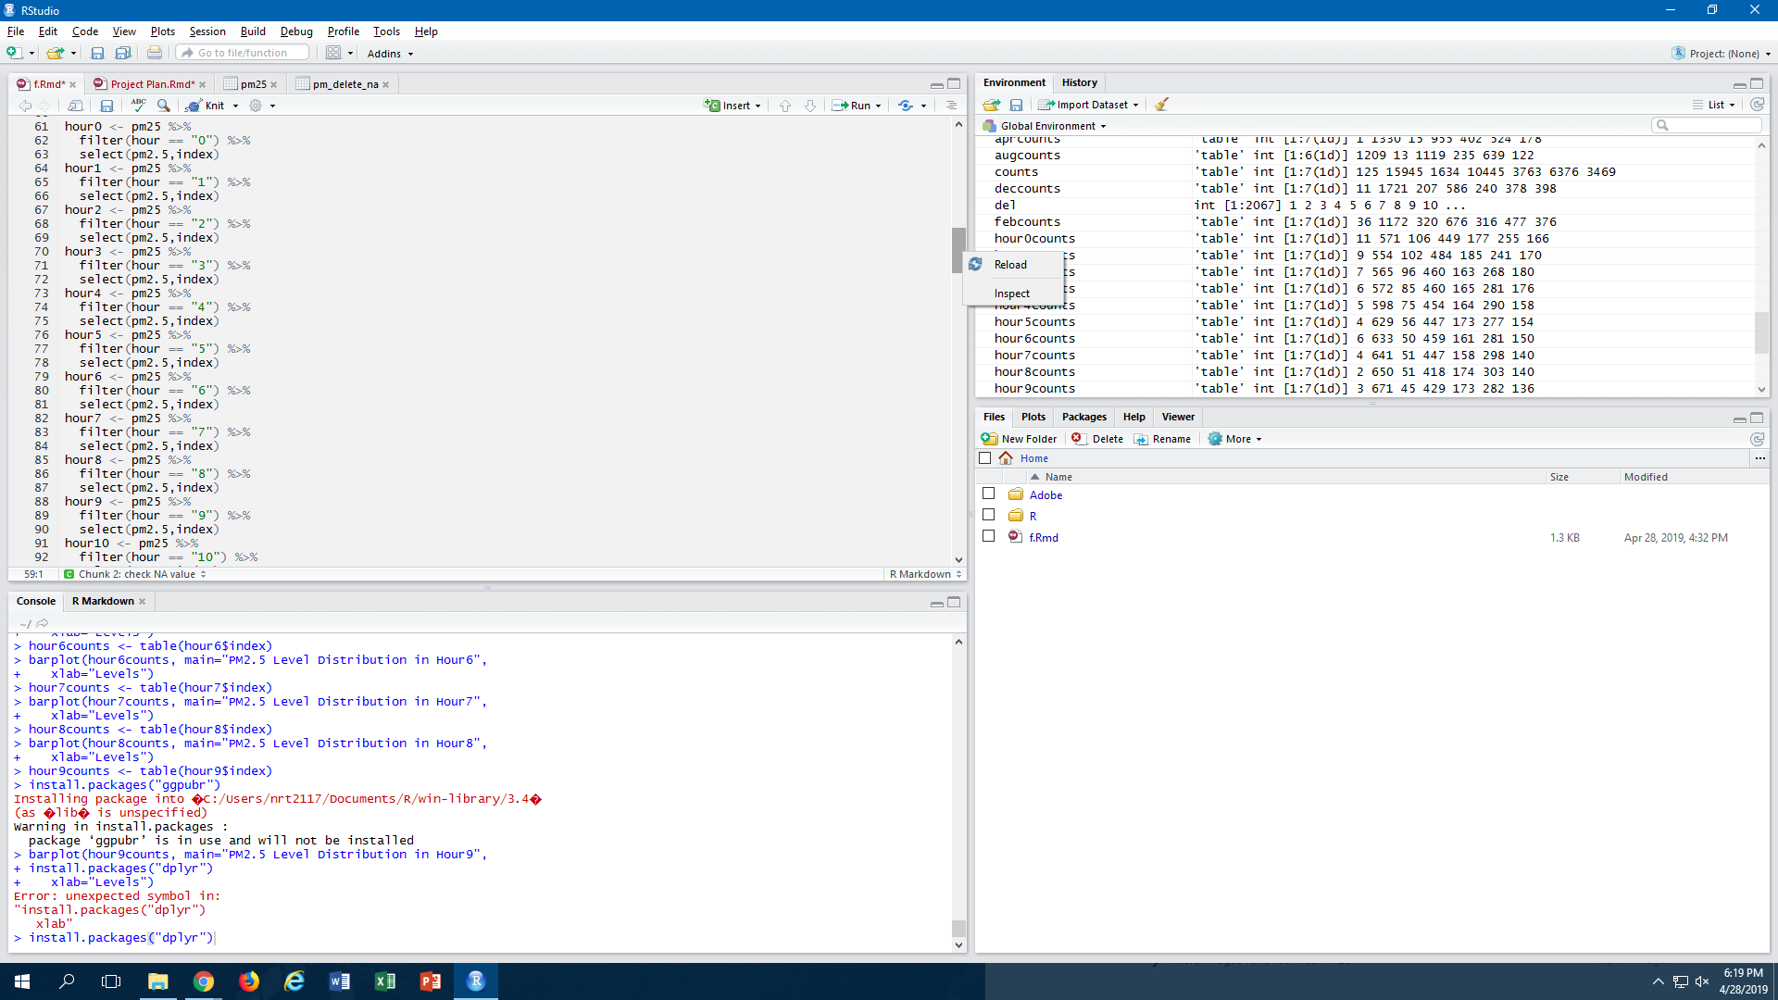

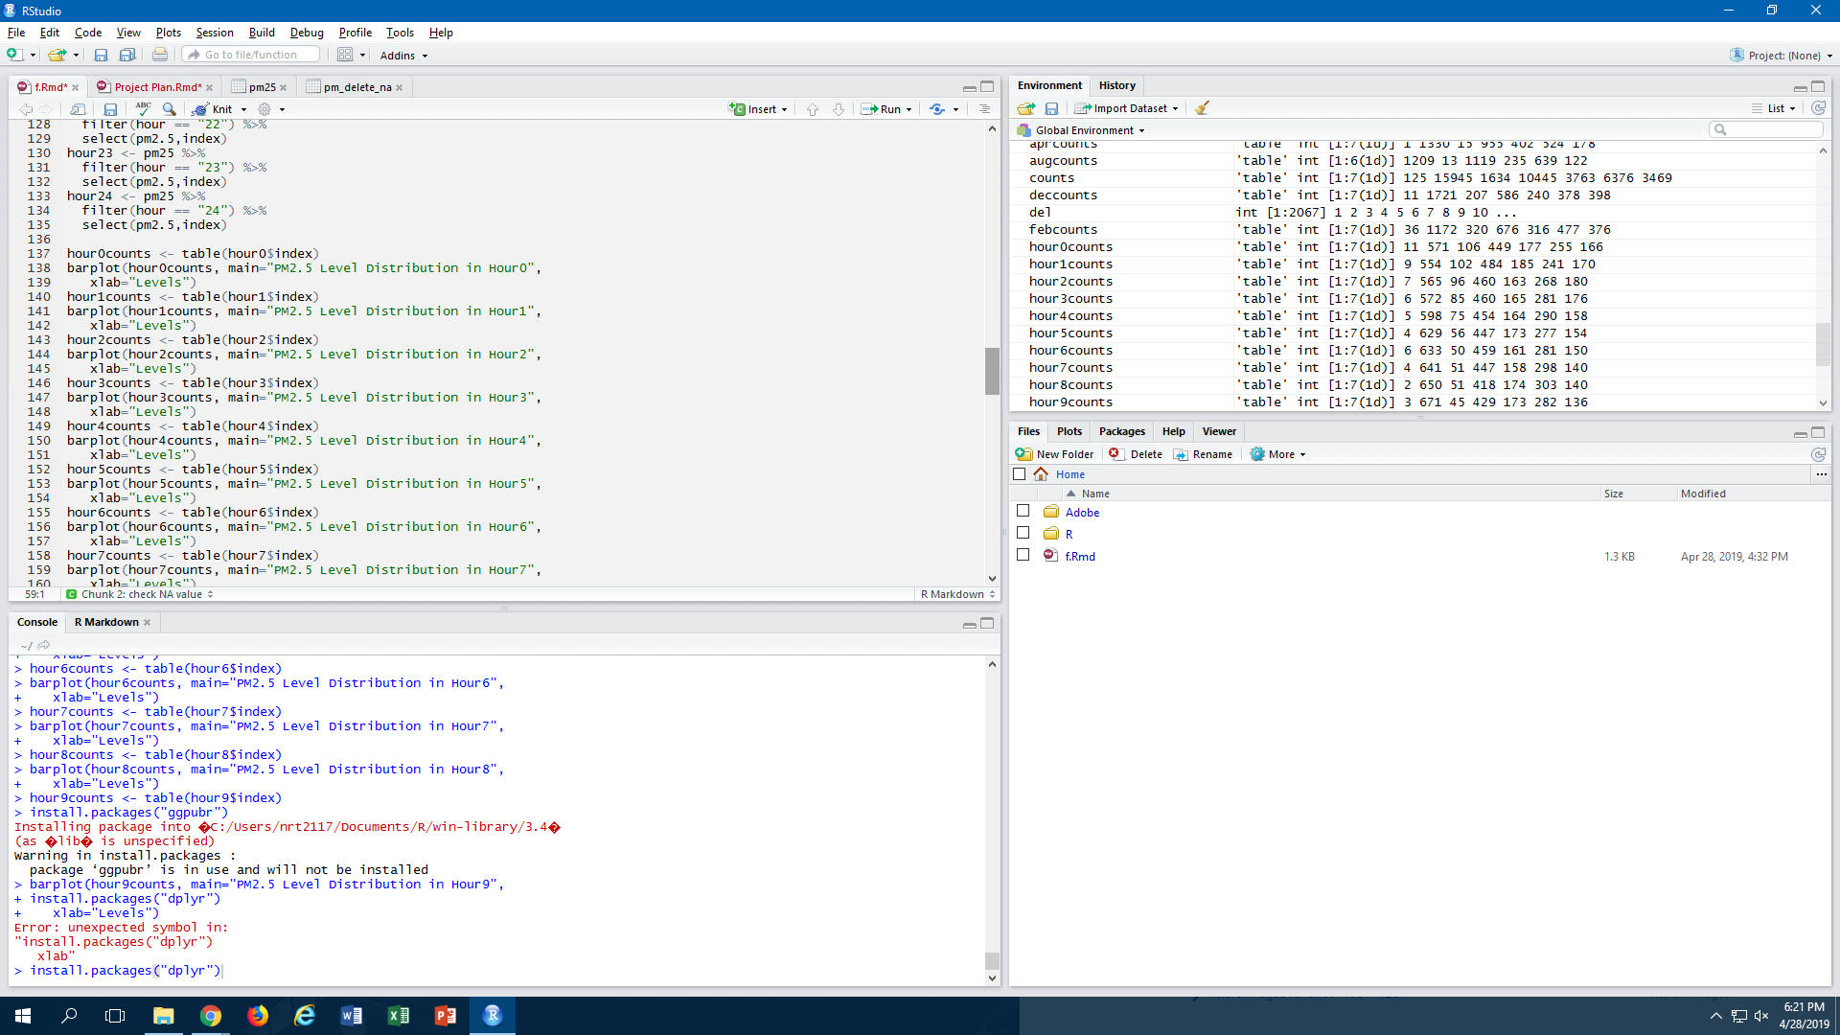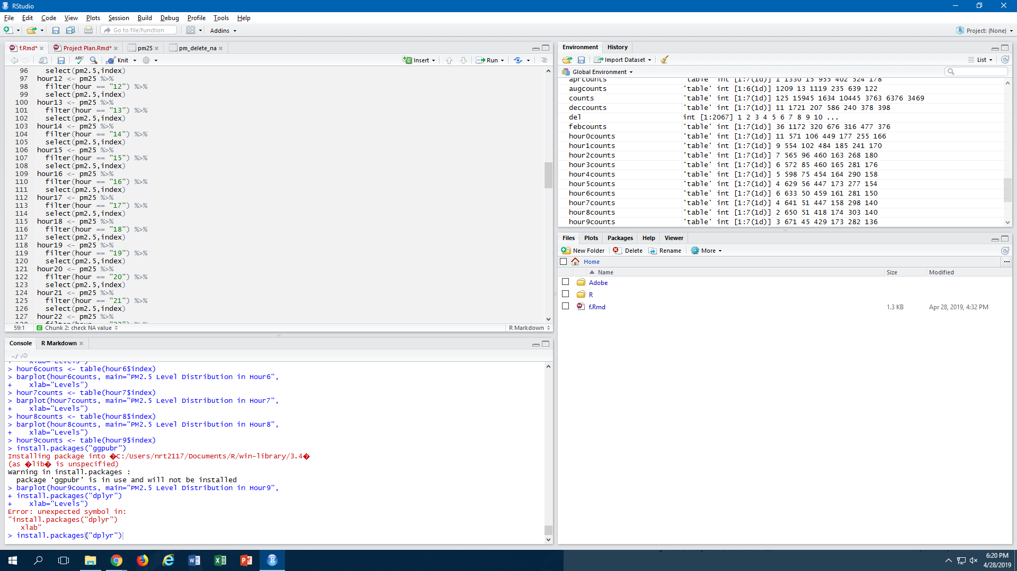

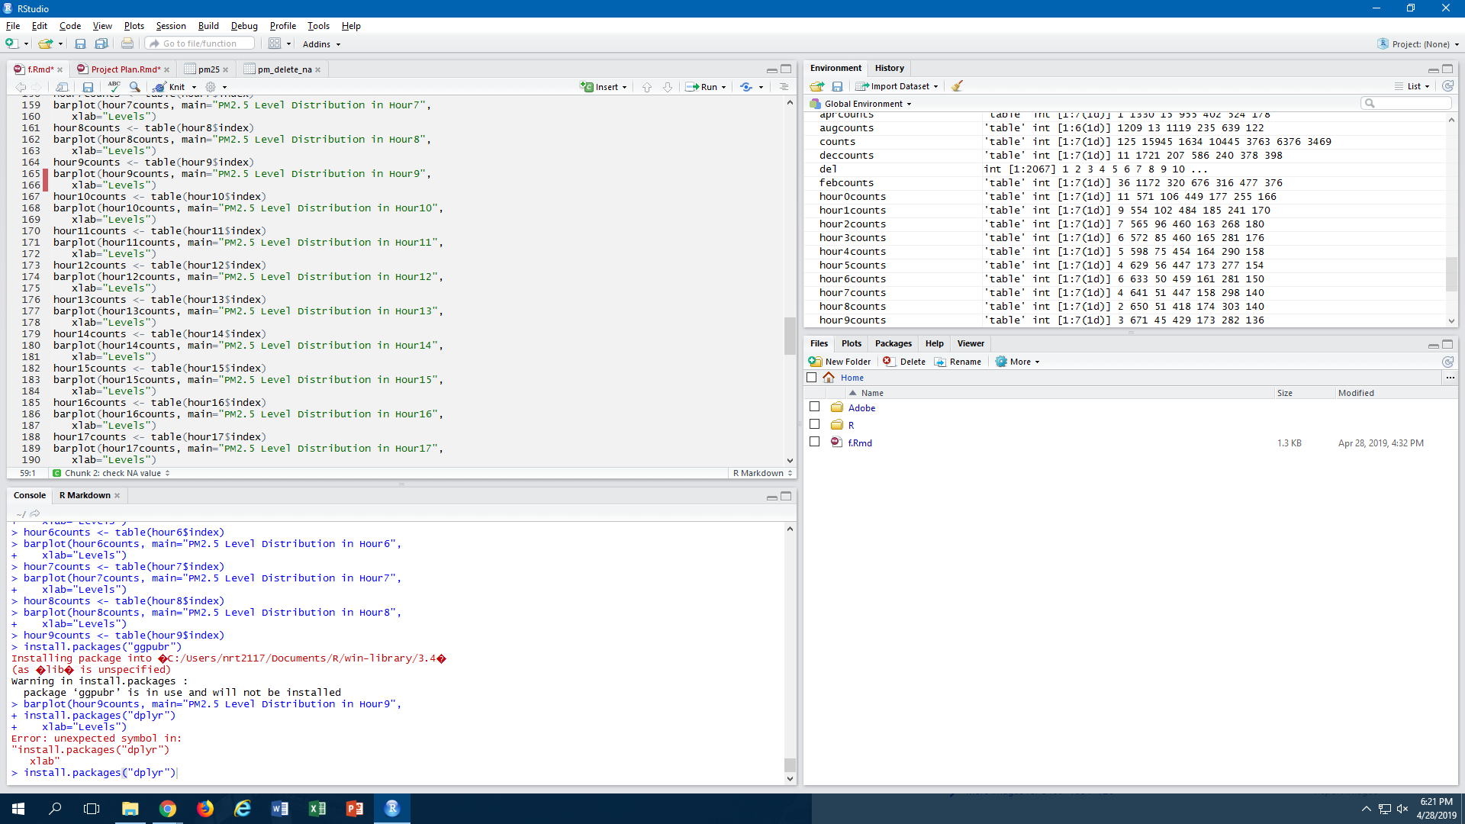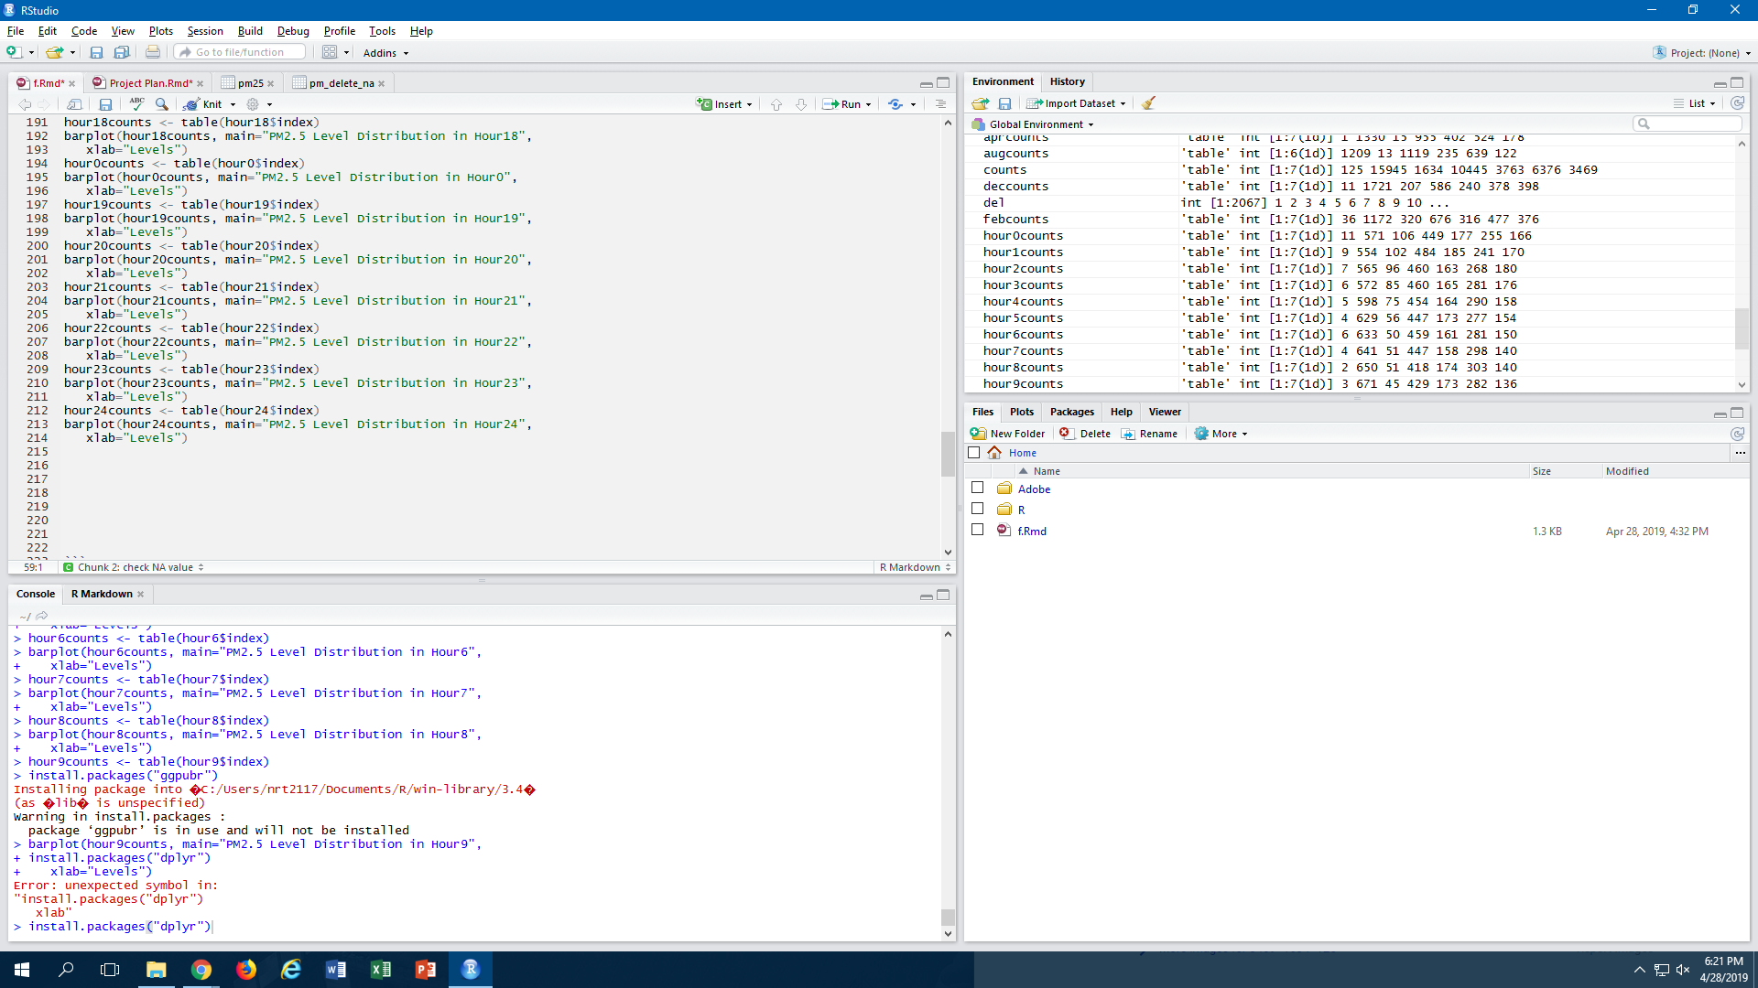

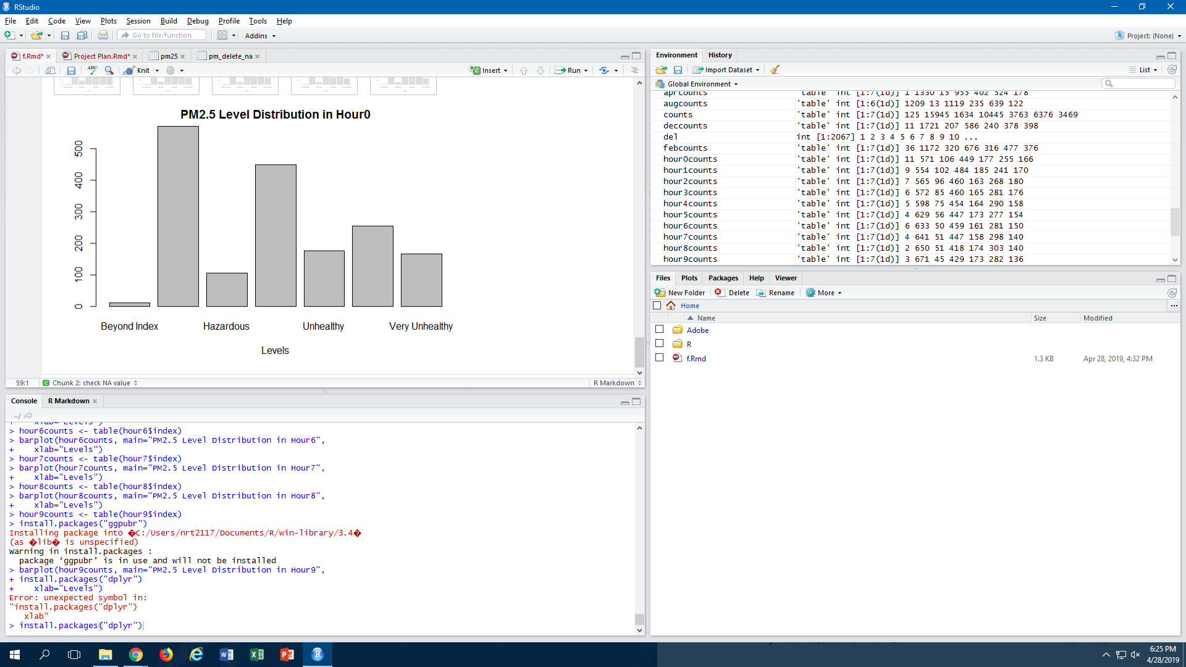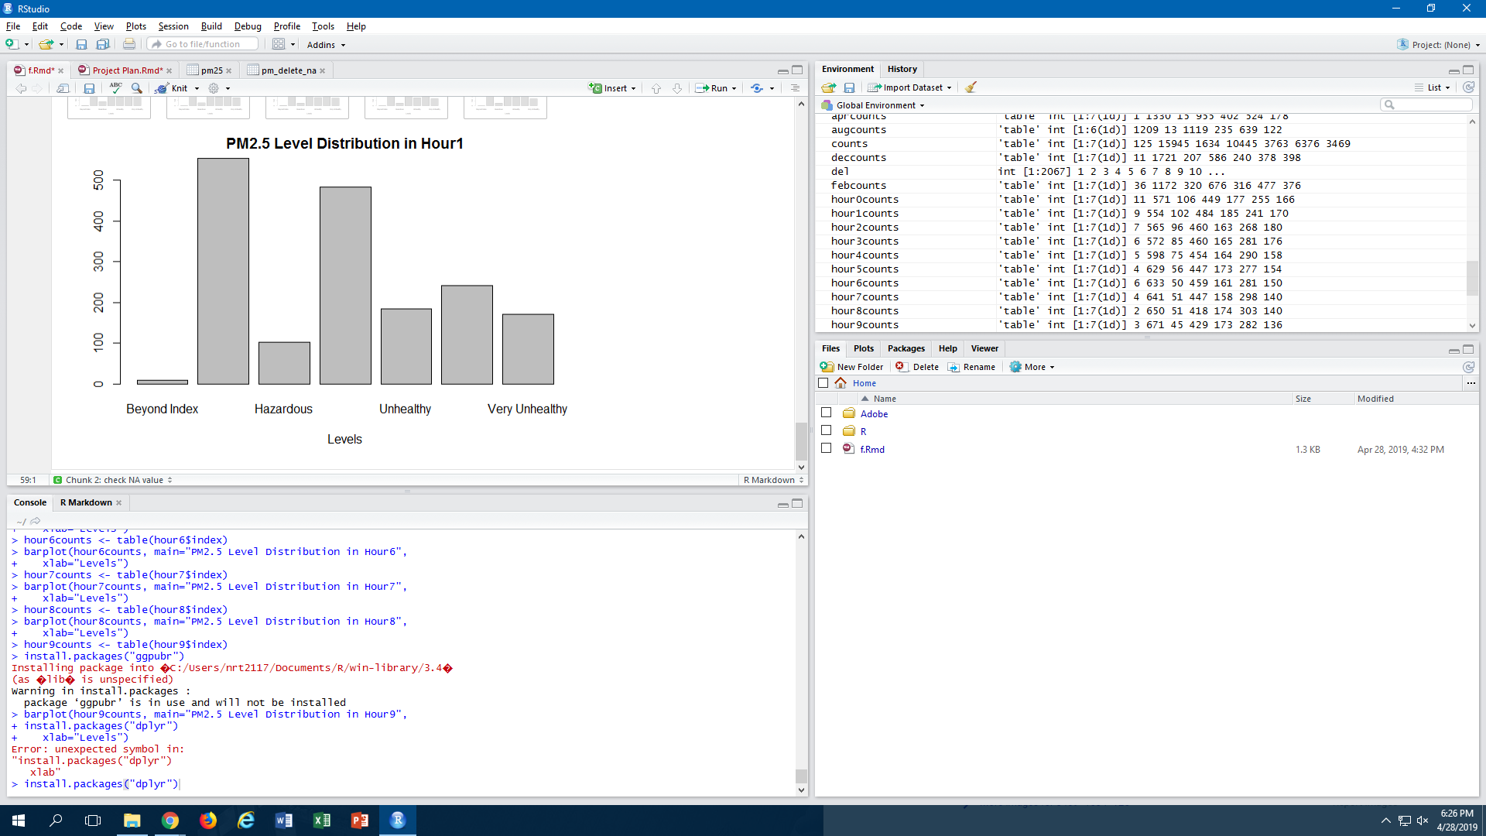

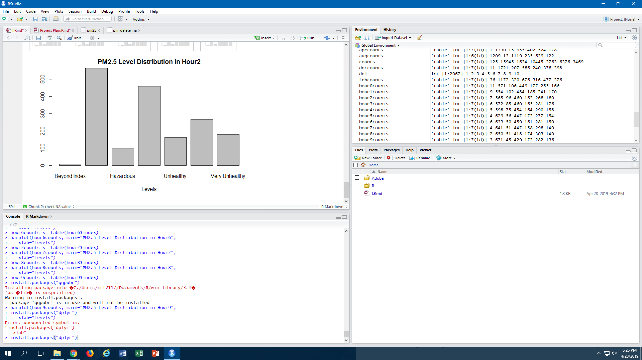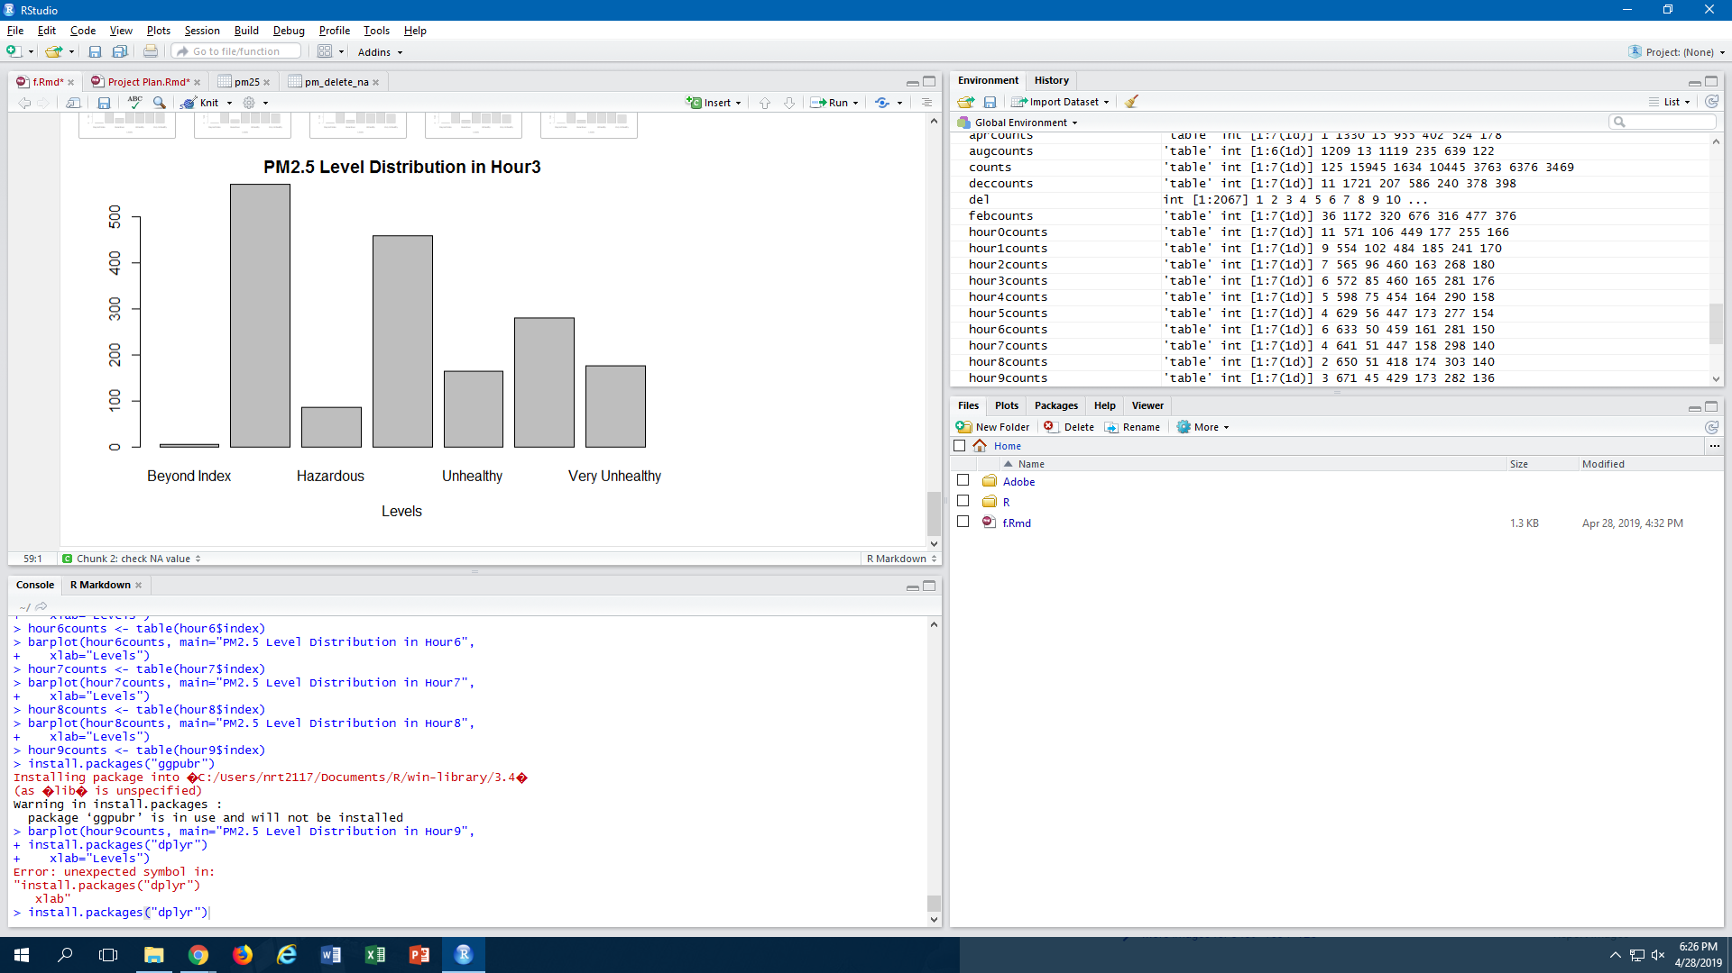

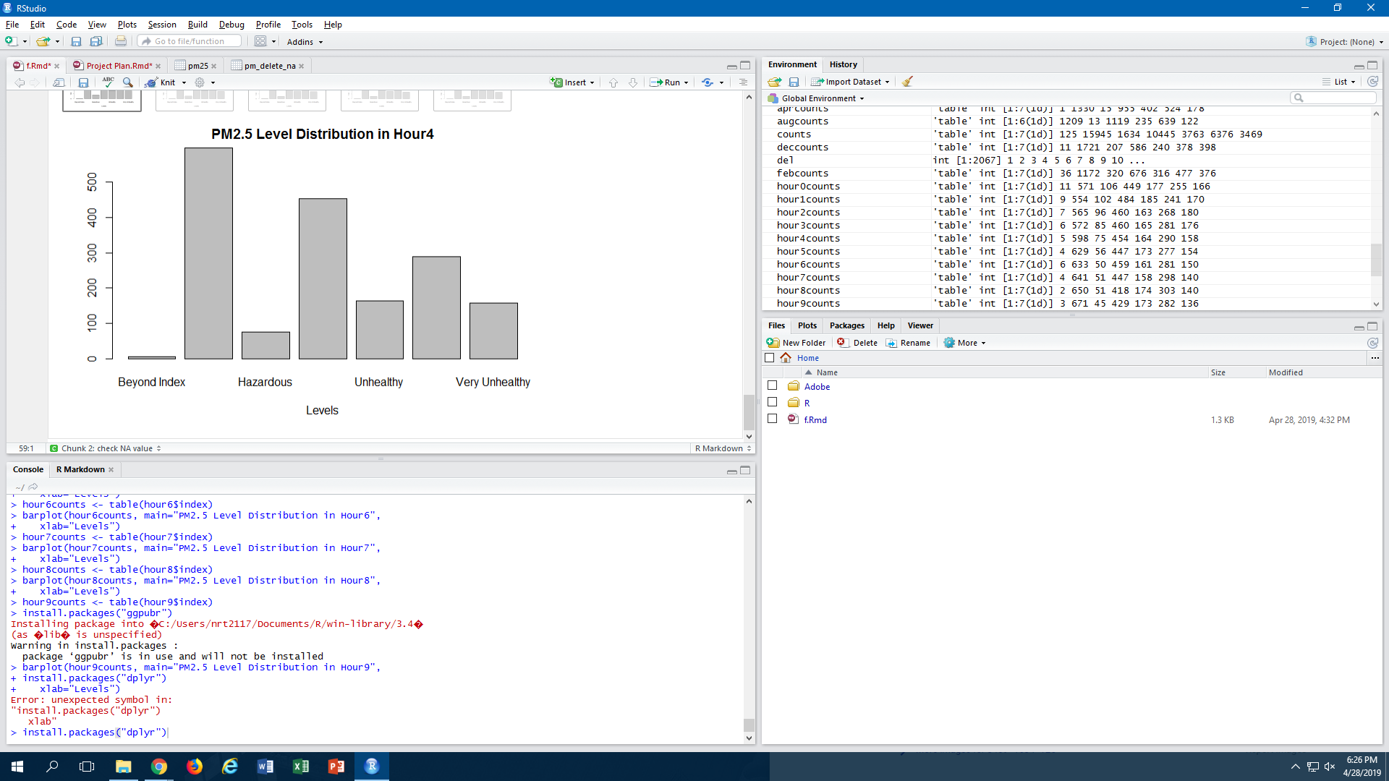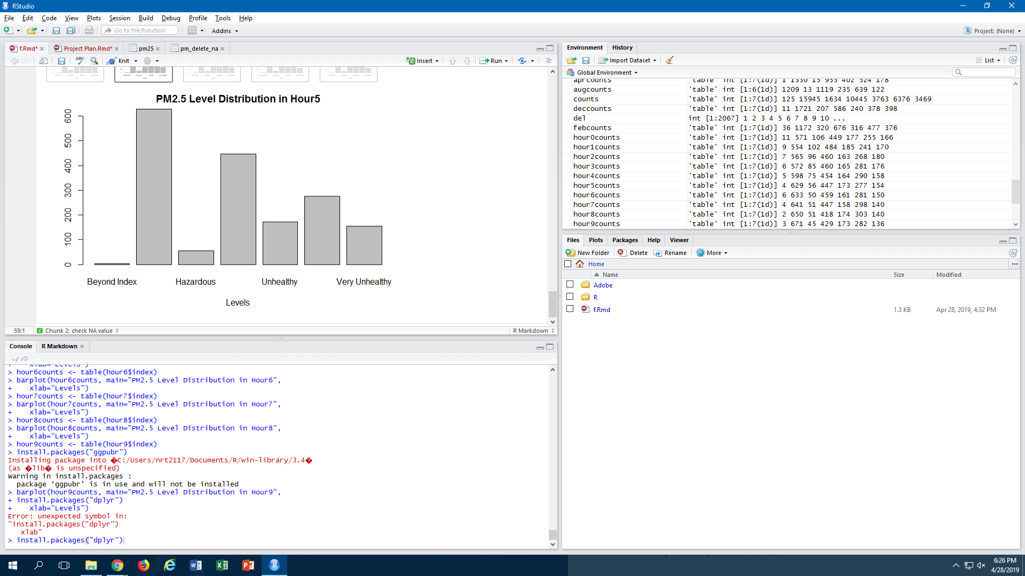

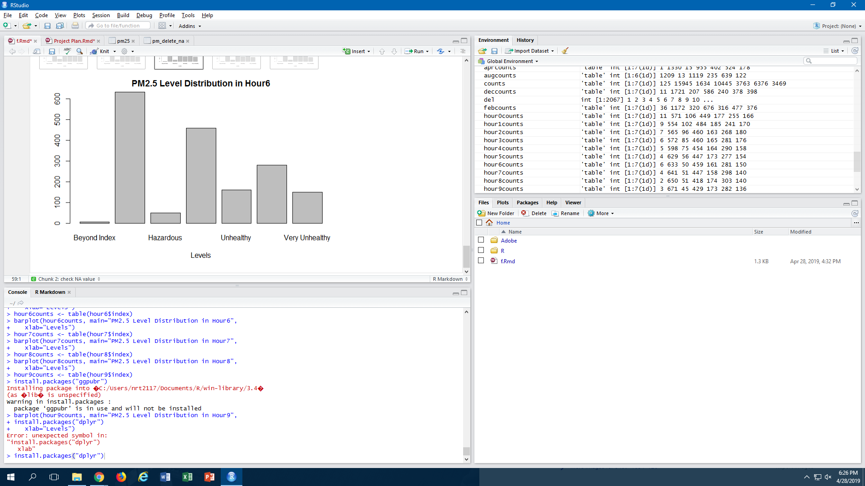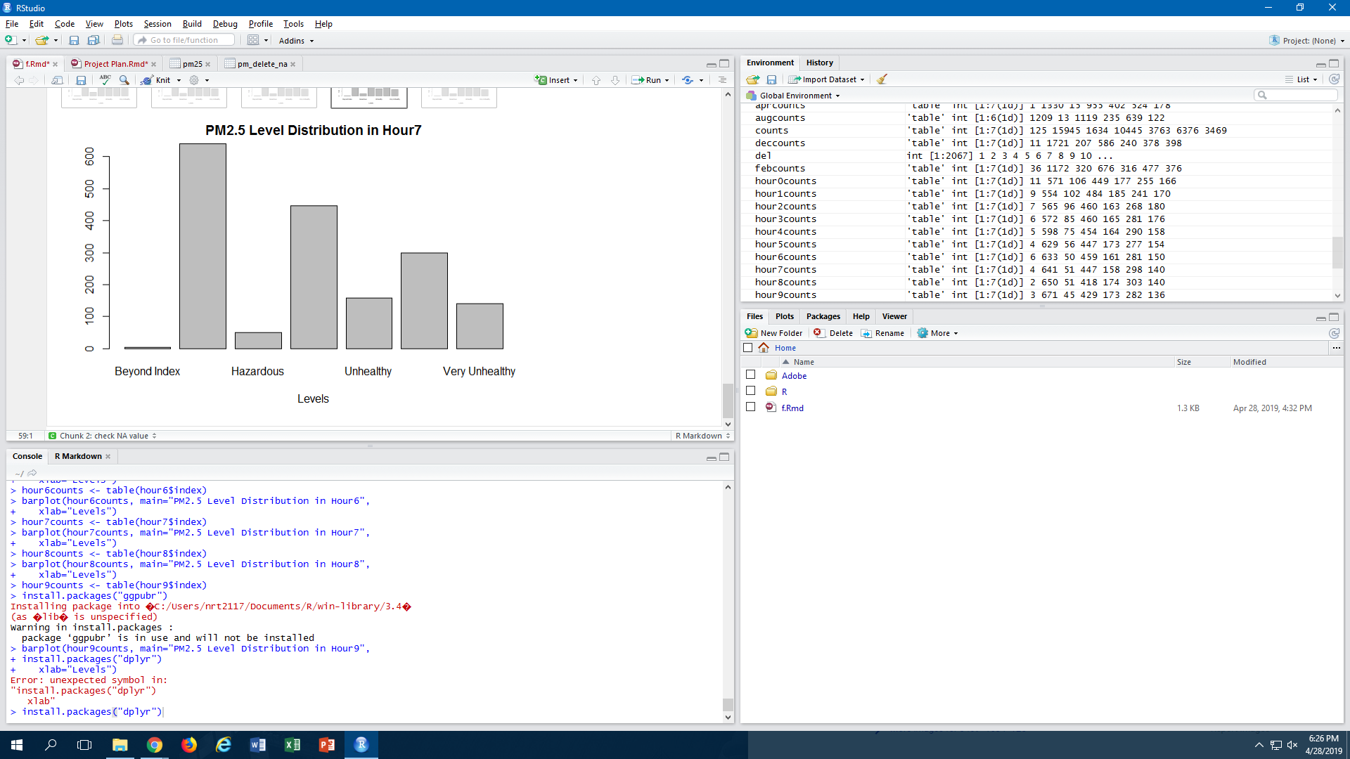

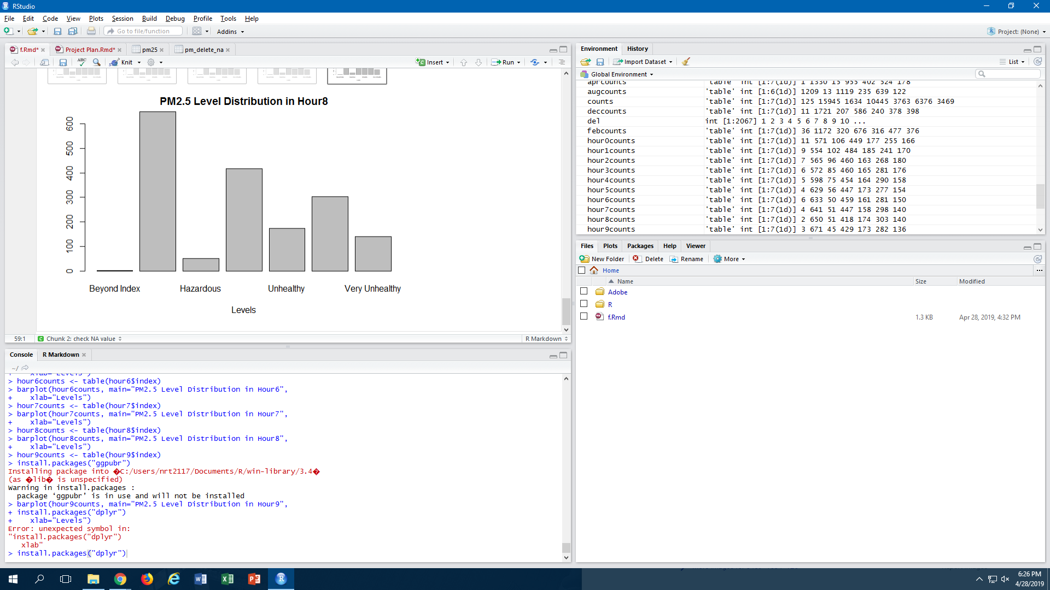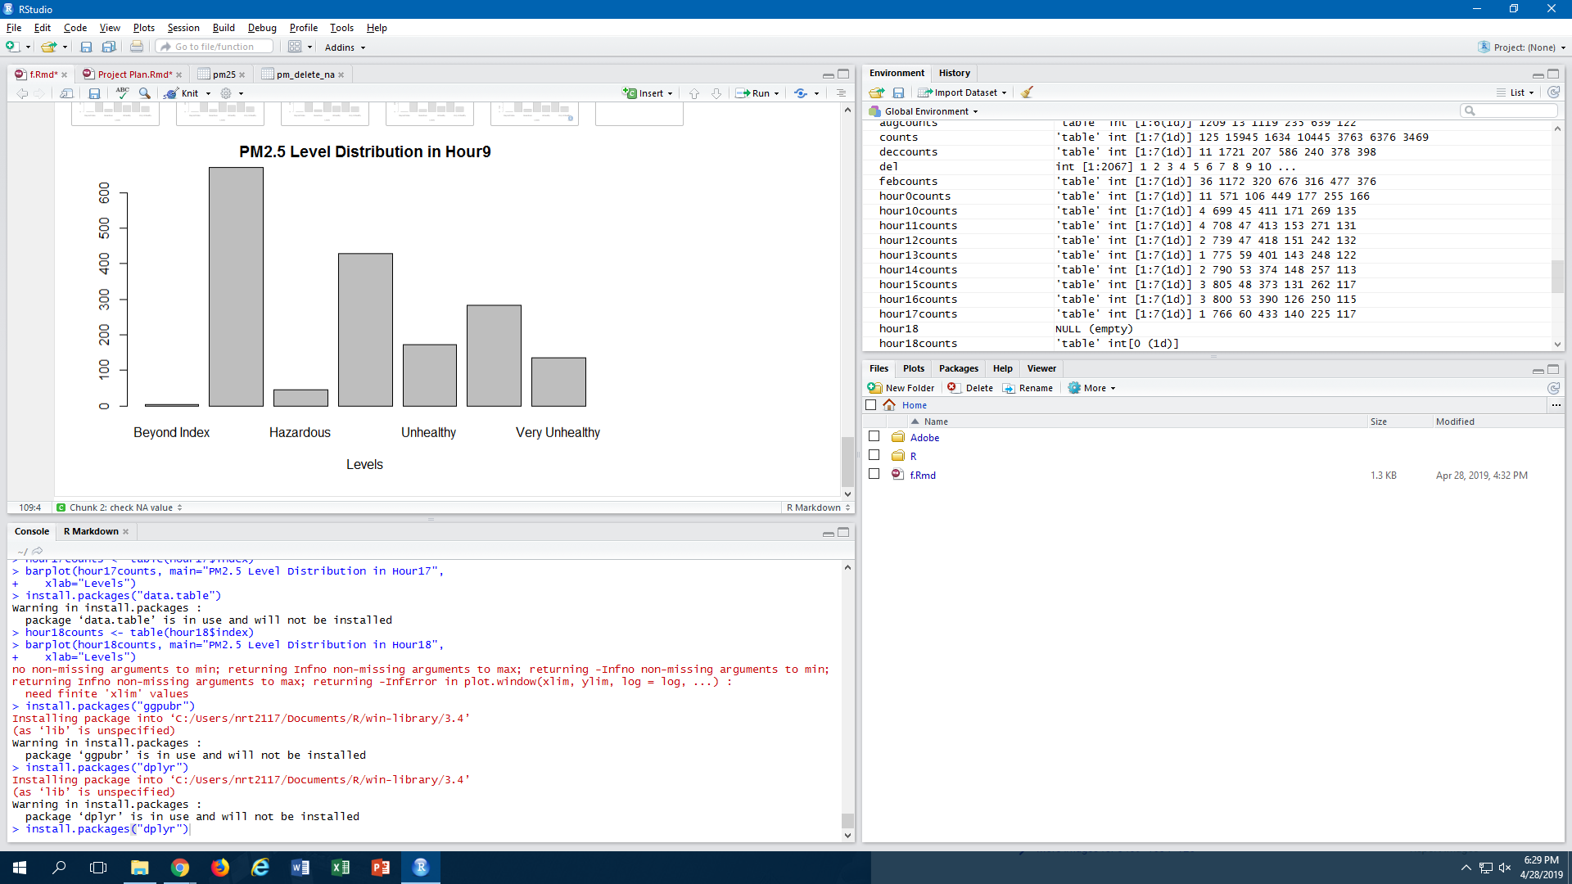

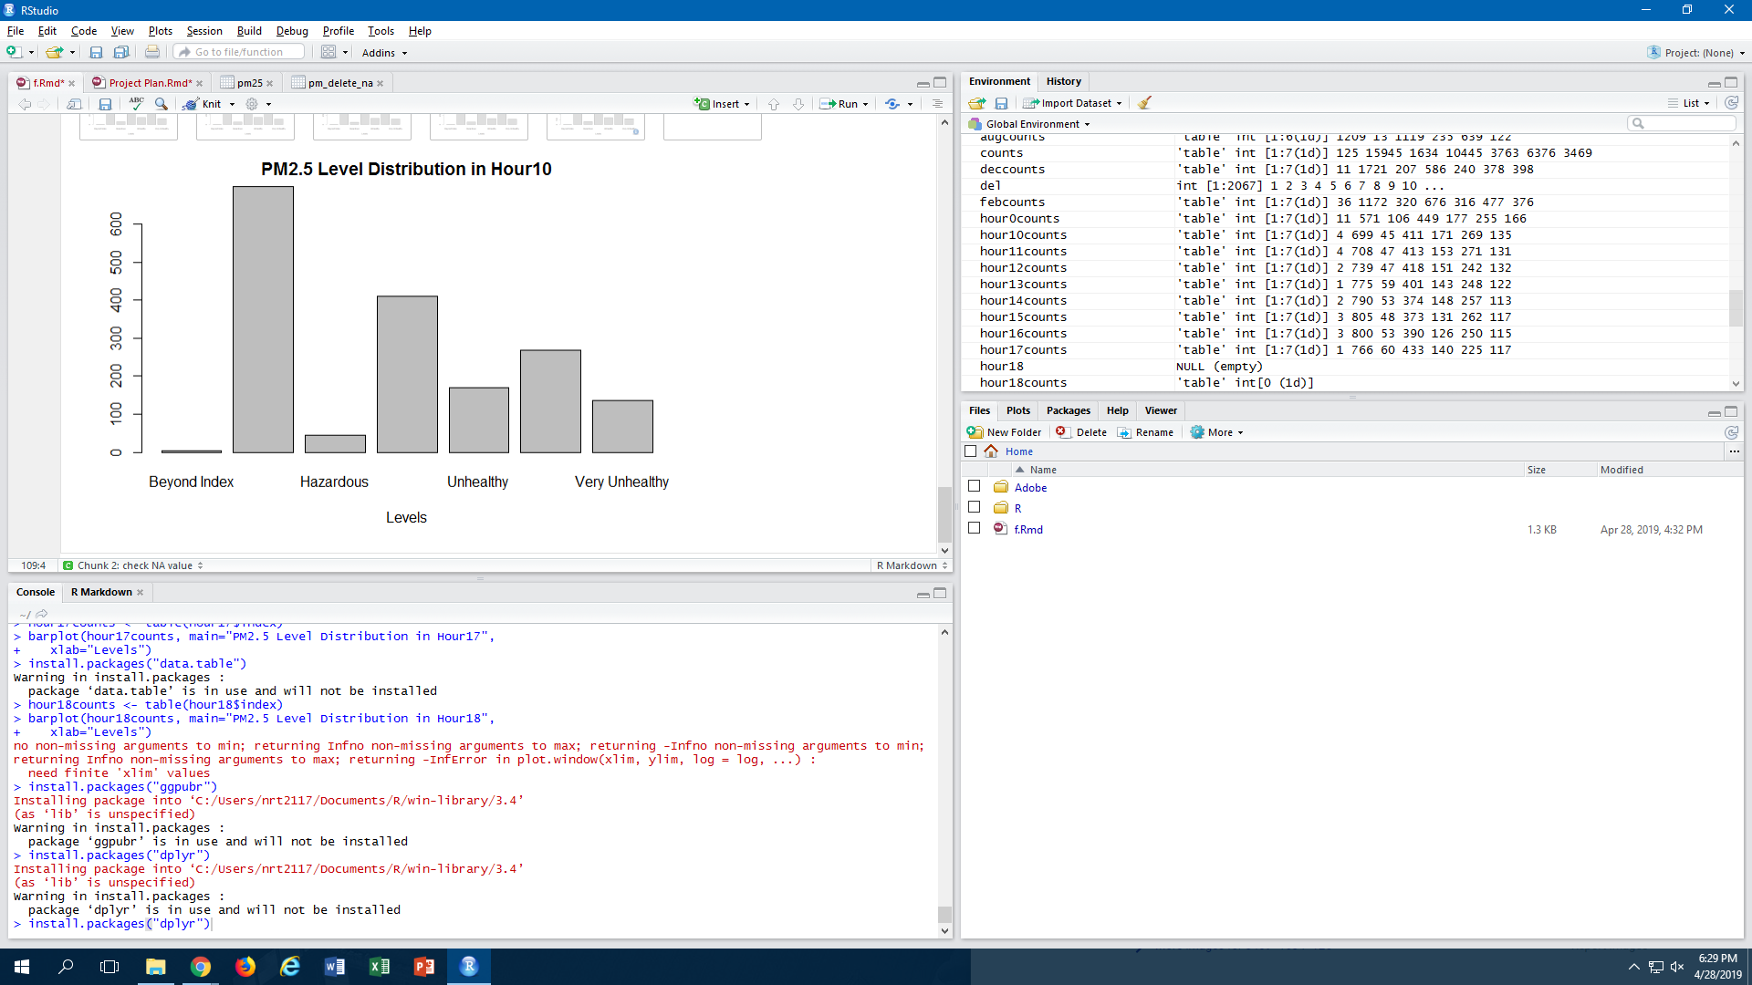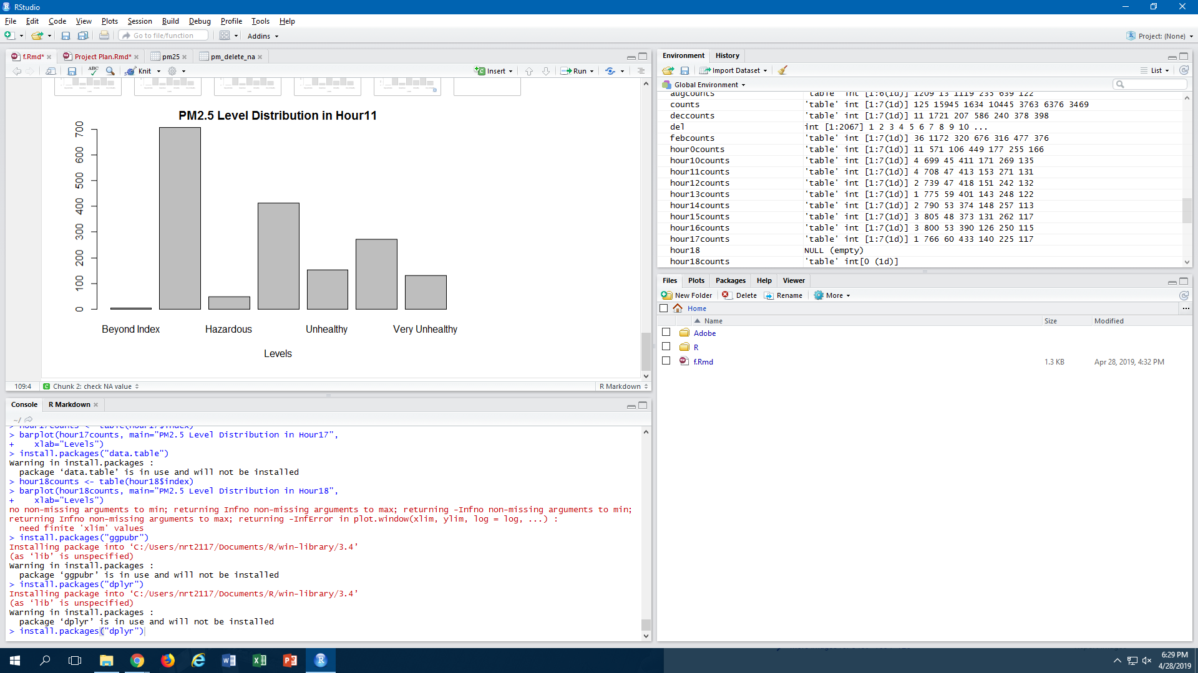

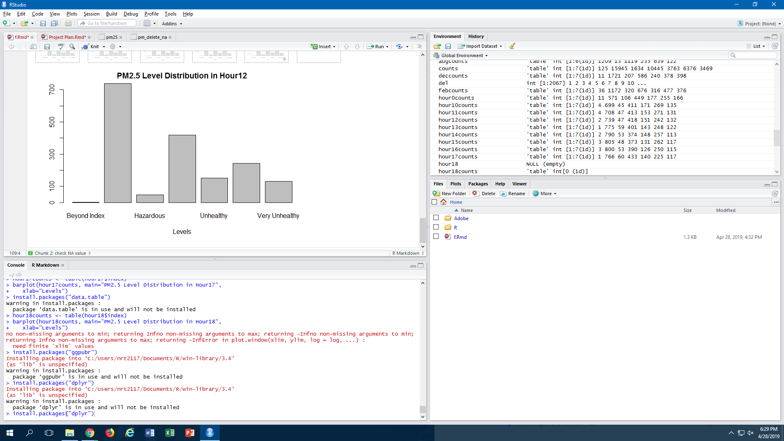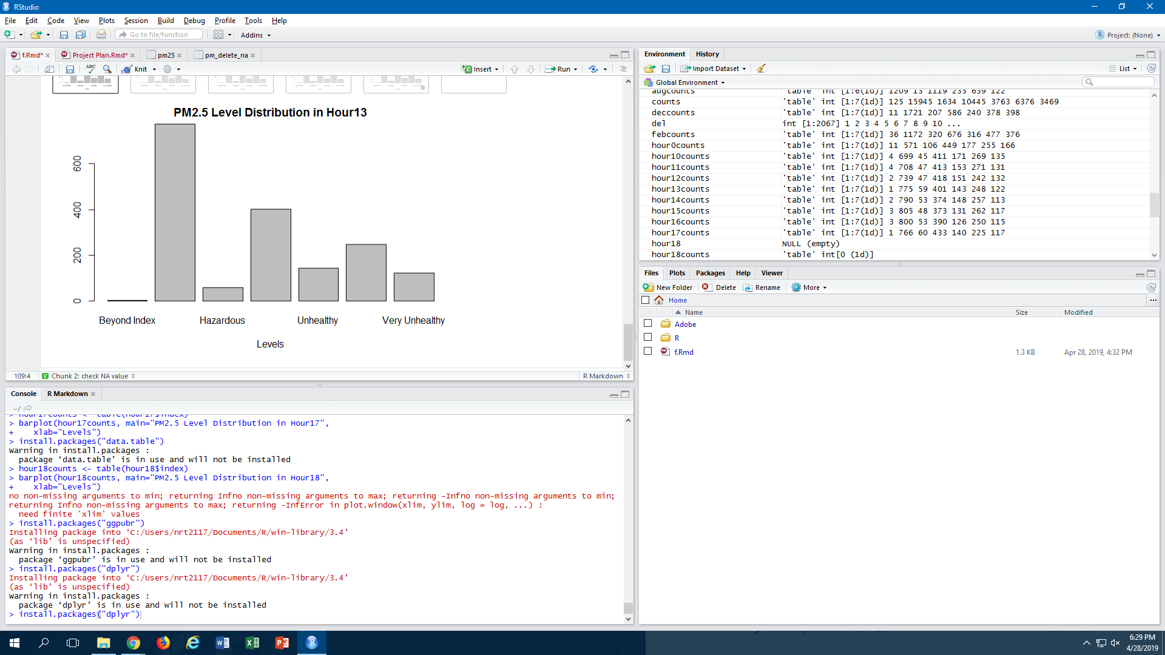

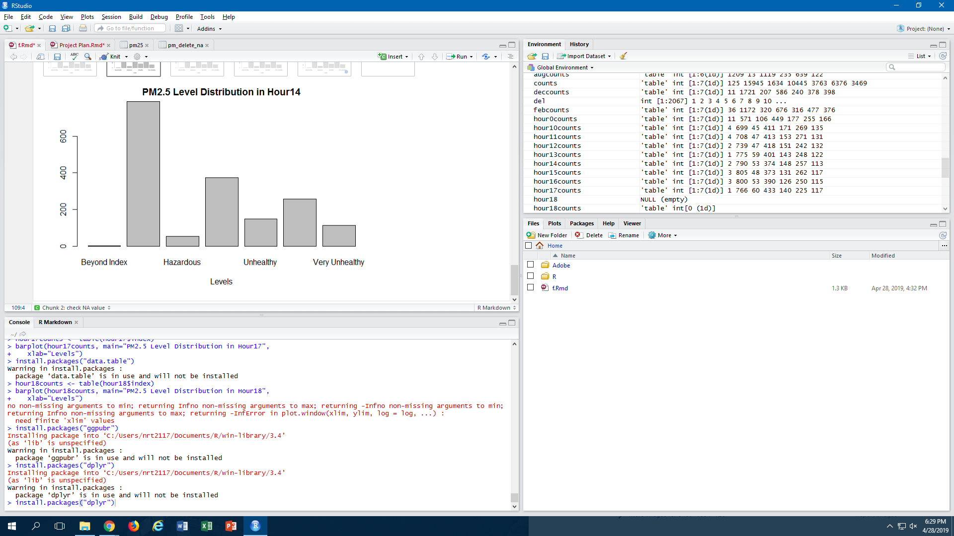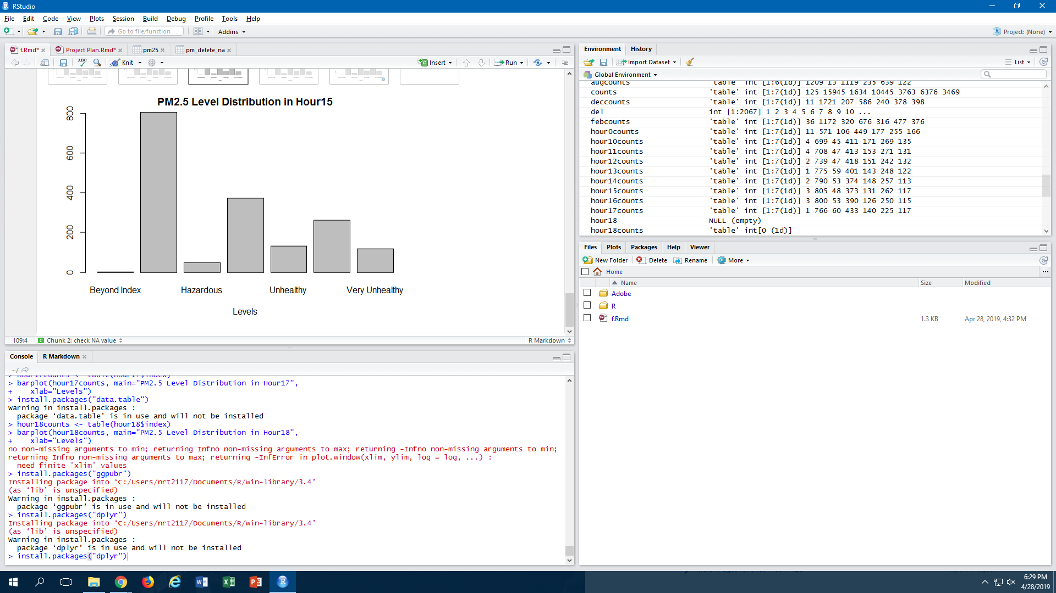

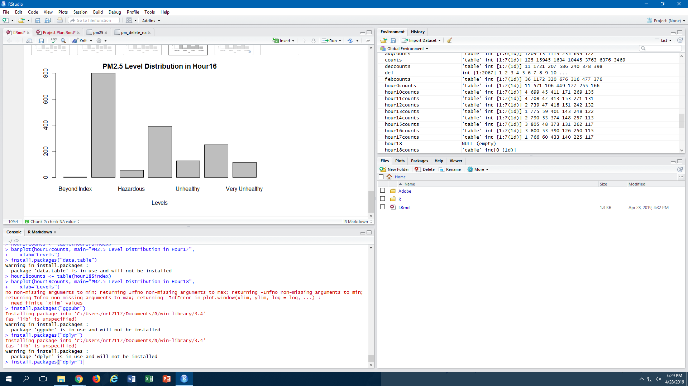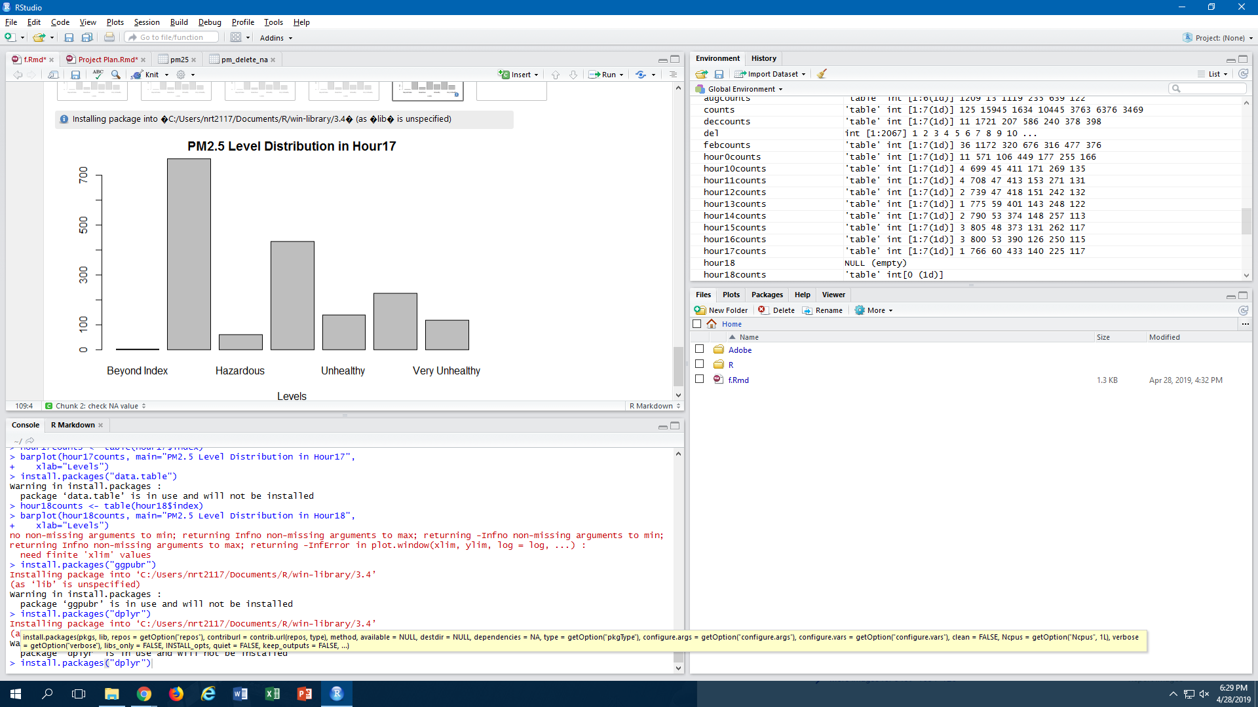

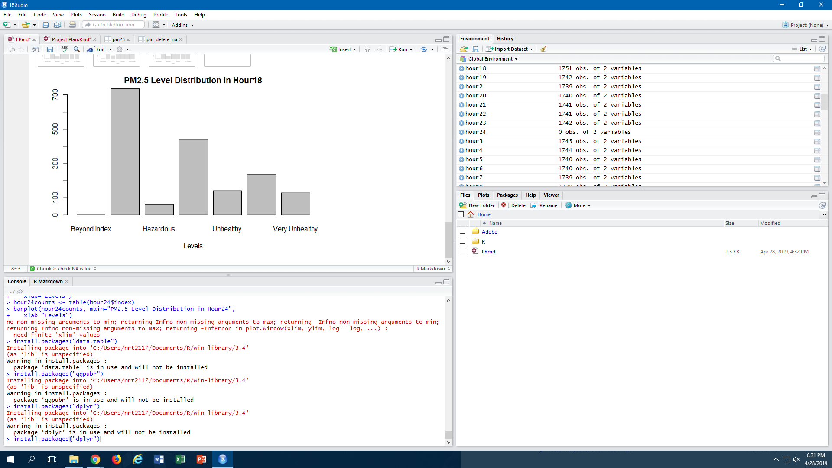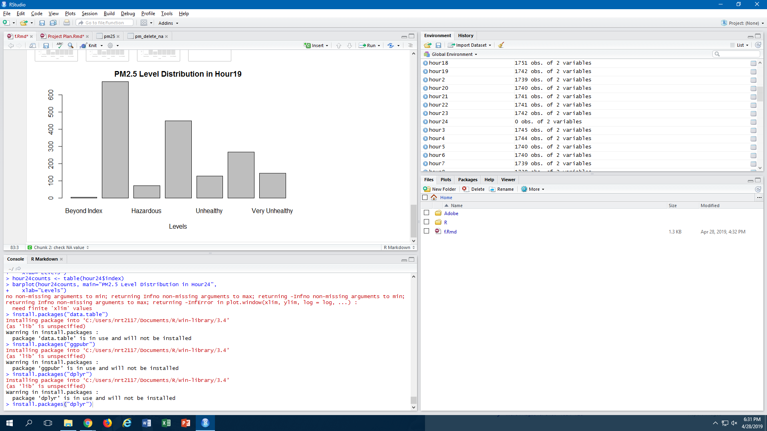

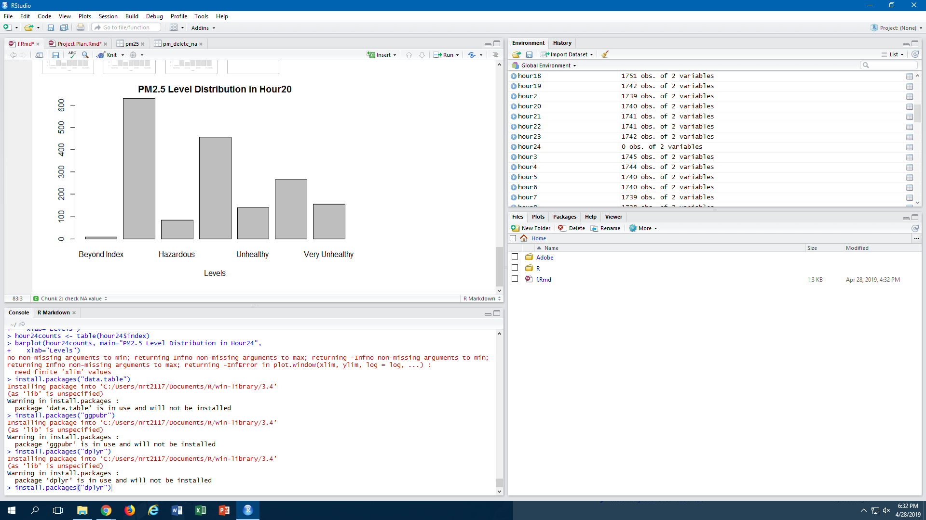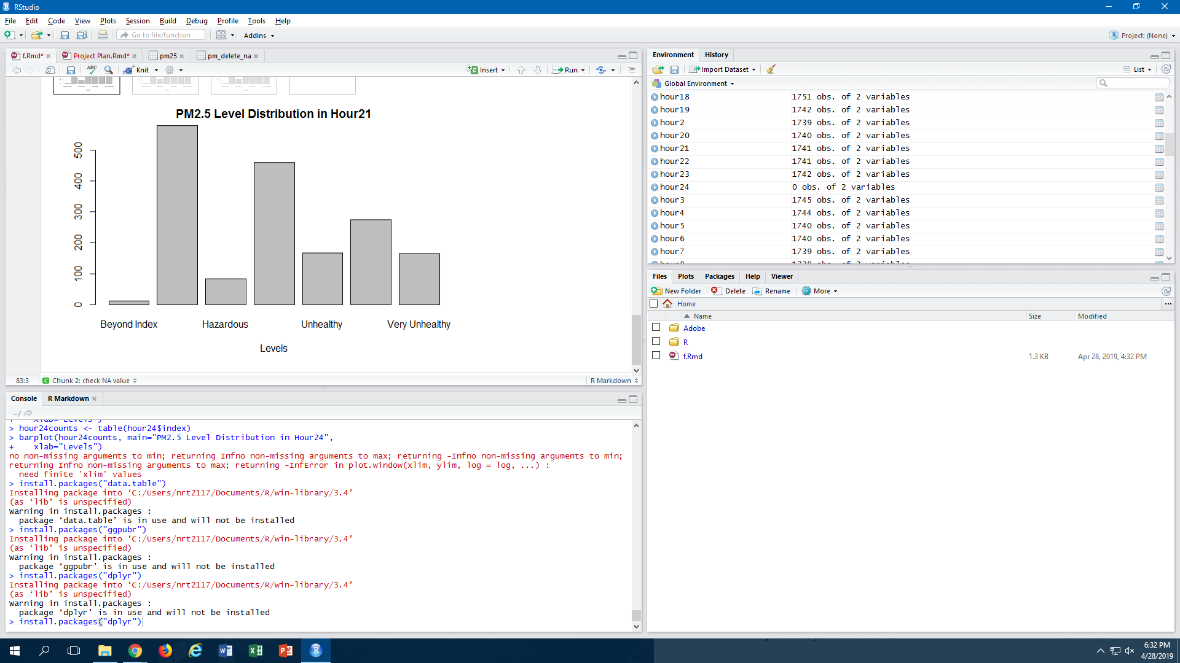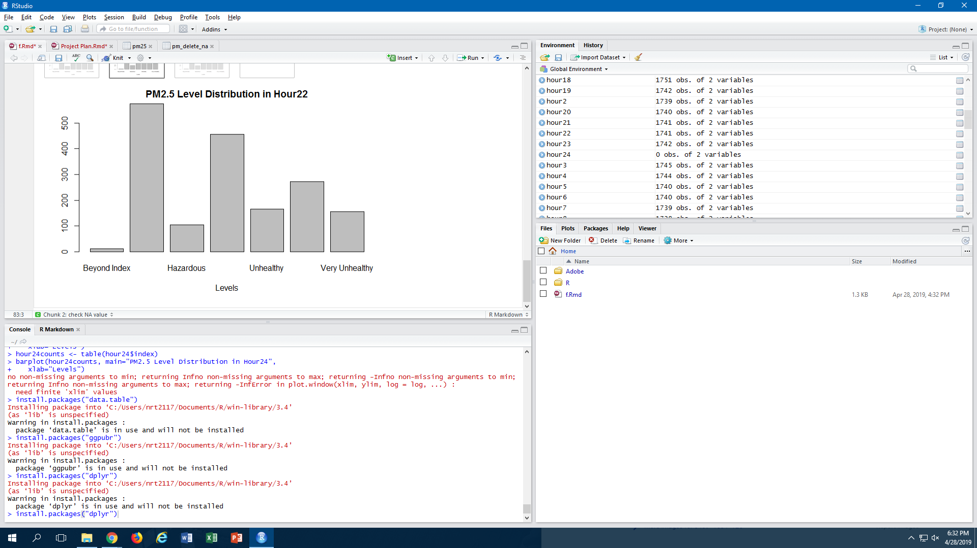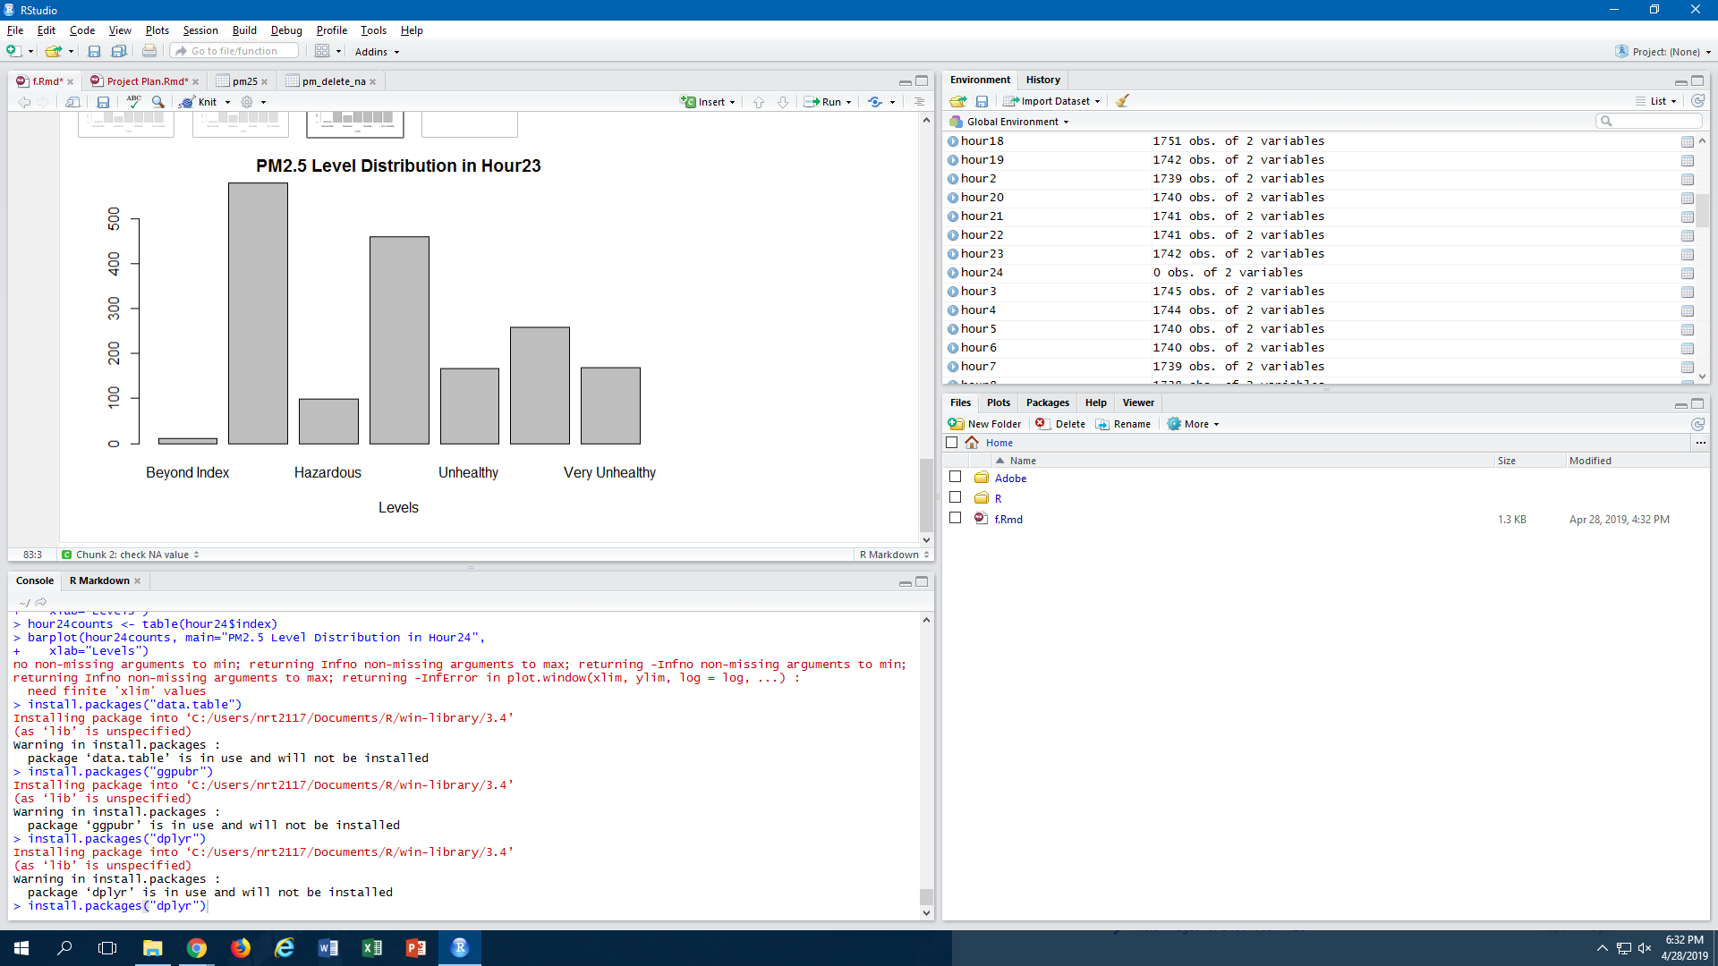

From the graphical representation above, we can summarize the following about the 24-hour period:

|  |  |  |
| --- | --- | --- |
| **Month** | **Proportion of “Very Unhealthy / Hazardous / Beyond Index” Category** | **Summary** |
| Hour 0 | 16.3% | Higher than average **(HIGHEST)** |
| Hour 1 | 16.3% | Higher than average **(HIGHEST)** |
| Hour 2 | 16.3% | Higher than average **(HIGHEST)** |
| Hour 3 | 15.3% | Higher than average |
| Hour 4 | 13.6% | Higher than average |
| Hour 5 | 12.3% | Lower than average |
| Hour 6 | 11.8% | Lower than average |
| Hour 7 | 11.2% | Lower than average |
| Hour 8 | 11.1% | Lower than average |
| Hour 9 | 10.6% | Lower than average |
| Hour 10 | 10.6% | Lower than average |
| Hour 11 | 10.5% | Lower than average |
| Hour 12 | 10.5% | Lower than average |
| Hour 13 | 10.4% | Lower than average |
| Hour 14 | 9.7% | **Lower than average (LOWEST)** |
| Hour 15 | 9.7% | **Lower than average (LOWEST)** |
| Hour 16 | 9.8% | Lower than average |
| Hour 17 | 10.2% | Lower than average |
| Hour 18 | 11.1% | Lower than average |
| Hour 19 | 12.6% | Higher than average |
| Hour 20 | 14.1% | Higher than average |
| Hour 21 | 15.0% | Higher than average |
| Hour 22 | 15.6% | Higher than average |
| Hour 23 | 16.0% | Higher than average |

Similar to the seasonal distribution, it seems that there is a 24-hour distribution of PM2.5 levels too. The levels tend to be higher in the night, and lower in the day. One take note of how there is a smaller variation in results than the seasonal distribution.

Overall, these statistics have given us a better understanding of just how severe the PM2.5 levels are in Beijing.